**Cartography Tool v6.0.0**

**User guide**

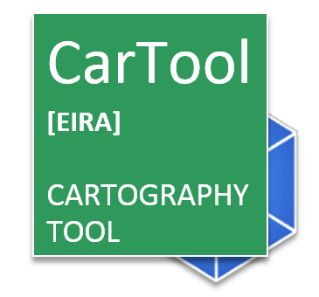



Change Control

|  |  |
| --- | --- |
| Modification | Details |
| Version 6.0.0 | |
| The newrelease of the CarTool includes:   * Support for EIRA v6.0.0; * Support for EIRA v5.0.0; * Support for eGovERA BA RA v6.0.0, eGovERA Health RA v6.0.0, eGovERA Customs RA v6.0.0, eGovERA Taxes RA v6.0.0. All of them has support to Data Spaces; * Support for the ELIS 5.0.1; * Support for the ELAP 2.0.0; * Alignment of the CarTool to the new Archi version 5.1.0; * Removal of the TES Cartography from public version. * Standardisation of the installation: The CarTool can be installed like any other Archi plugin; | |
| Version 5.0.0 | |
| The new release of the CarTool includes:   * Support for EIRA v5.0.0; * New structure for the CarTool folders; * Support for the ELIS 1.1.0; * Support for the ELAP 1.0.0. * Update the ELAP with the new version.  1. Add button to recall the static list of the architectural principles (View Available Architecture Principle) 2. Enable to select and add (stereotype) the one of interest as Architecture Principle as ELAP. 3. Change the column header of the ELAP.  * Upgrade the project from JAVA 8 to JAVA 11 in order to be compatible with the new Archi versions 4.9.2 and 4.9.3. | |
| Version 4.1.0 | |
| The new release of the CarTool includes:   * Support for EIRA v4.1.0; * New structure for the CarTool folders; * Support for the ELIS 1.1.0; * Support for the ELAP 1.0.0. | |
| Version 4.0.0 | |
| The new release of the CarTool includes:   * Support for EIRA v4.0.0; * New structure for the CarTool folders; * Possibility to import National Solution Architecture Templates (both High-Level and Detail-Level SATs); * Qualifier for the imported Reference Architectures and Detail-Level/High-Level Solution Architecture Templates; * Possibility to stereotype Interoperability Requirements ABBs in a High-Level Solution Architecture Template. | |
| Version 3.1.0 | |
| The new release of the CarTool includes:   * Support for EIRA v3.1.0 * Re-engineered the building block pop-up window, increasing the user readability * Upgrade to ELIS v1.0.0 * Possibility to consult the CAMSS assessment of ELIS specifications, by right-clicking on the ELIS specification of interest * Enriched description of the ELIS specifications * Possibility to import a reference architecture in .archimate format * Possibility to import library of interoperability specifications in .ttl format * Upgrade of the Catalogue of Services SAT to version v3.0.0 | |
| Version 3.0.0 | |
| Introduced the description of the CarTool Structure.  Modified the overview of the features of the CarTool.  Modified the “Inspecting the EIRA, the EIRA Extension Library and My Library” section, “Accessing interoperability specifications” section and the “Creating and updating solutions and SATs” sections.  Added the instructions to consult the ELIS (European Library of Interoperability Specifications) and to consult the online documentation of the building blocks in joinup. | |
| Version 2.2.0 | |
| Modified installation instructions for EC users.  Added install instructions for European Interoperability Cartography (EIC) solution. | |
| Version 2.1.0 | |
| Updated CarTool upgrade procedure. | |
| Version 2.0.1 | |
| New update URL and Joinup structure. | |
| Version 2.0.0 | |
| Aligned with EIRA release v2.0.0 |  |
| Version 1.0.0 | |
|  |  |

|  |
| --- |
| ArchiMate® is a registered trademarks of The Open Group.  ArchiMate© is copyright of The Open Group. All rights reserved.  Archi® is a registered trademark of Phillip Beauvoir. |

TABLE OF CONTENTS

1 Introducing the CarTool 7

1.1 What is the CarTool? 7

1.2 What can I use it for? 7

1.3 What are the CarTool’s benefits? 7

1.4 Where can I get more information? 8

1.5 How do I provide feedback or request a change? 8

2 Installation 9

2.1 Installation prerequisites 9

2.2 Installing Archi® 9

2.2.1 Installing Archi® for External to EC users 9

2.2.2 Installing Archi® for European Commission users 10

2.3 Installing the CarTool for External to EC users 10

2.3.1 Upgrading the CarTool for External to EC users 11

2.3.2 The European Interoperability Cartography (EIC) for External to EC users 12

2.4 Getting started with the CarTool 13

2.5 Updating the EIRA, the CarTool and the Cartography 14

2.6 Updating Archi® for External to EC users 14

2.7 Removing the CarTool for External to EC users 15

3 Overview of features 16

3.1 CarTool controls and panels 17

3.2 Adapting the CarTool to suit your needs 20

3.2.1 Example 1: Focus on solution modelling 20

3.2.2 Example 2: Focus on querying the Cartography 21

4 Inspecting the EIRA, the EIRA Extension Library and My Library 22

4.1 Structure of the CarTool 22

4.2 Inspecting views and building blocks graphically 23

4.3 Inspecting views and building blocks in tabular form 25

4.3.1 Table contents when inspecting the EIRA 26

4.3.2 Table contents when inspecting EIC (European Interoperability Cartography) solutions. 26

4.3.3 Table contents when inspecting an SAT 27

4.3.4 Online Documentation 28

5 Creating and updating solutions or SATs 30

5.1 Creating a new solution or SAT 30

5.2 Adding building blocks to a solution or SAT 32

5.2.1 Avoiding building block duplication 35

5.3 Adding Building Blocks to a Solution or SAT from an imported Reference Architecture 35

5.4 Adding Building Blocks to a Solution or SAT from an imported High-Level or Detail-Level SAT 37

5.5 Updating a solution or SAT’s building blocks 39

5.6 Updating a solution or SAT from the Cartography 40

5.7 Submitting a TES or SAT update to the Cartography (European Commission only) 40

6 Accessing interoperability specifications 42

6.1 Consult the European Library of Interoperability Specifications 42

6.2 Consult the European Library of Architecture Principles 43

6.3 Viewing available interoperability specifications 43

6.4 Viewing used interoperability specifications 44

6.5 Viewing Available Architecture Principles 45

6.6 Import of National Interoperability Specifications 47

7 Querying the Cartography 48

7.1 Selecting query items 48

7.2 Building the query 49

7.3 Running the query 50

7.4 Managing saved queries 51

8 Keeping the CarTool, Cartography copy and SATs up to date 53

8.1 Viewing the CarTool version and licensing information 53

9 Troubleshooting 54

9.1 Accessing the log file 54

9.2 Resetting the CarTool to its original state 54

9.3 Contacting support 54

9.4 Known issues and workarounds 54

10 Glossary 56

# Introducing the CarTool

The current chapter serves as a high-level introduction explaining what the Cartography Tool (CarTool for short) is, how you can use it, and who is its target audience.

## What is the CarTool?

The CarTool is a tool built by the European Commission’s ISA unit designed to provide support in using the European Interoperability Reference Architecture (EIRA) and accessing a portfolio (Cartography) of solutions that are documented using the EIRA. It is built as a plug-in for the popular open source ArchiMate® modelling tool Archi®, building upon its modelling capabilities and providing higher level EIRA support. The CarTool itself is open-source[[1]](#footnote-2) and distributed under the “ISA Product License v1.4” licence.

Using the CarTool assumes familiarity with the EIRA and its related concepts. In short, the EIRA is a reference architecture for delivering interoperable ICT solutions that support cross-border and cross-sector public services. It defines the required capabilities for promoting interoperability as a set of Architecture Building Blocks (ABBs) with Solution Building Blocks (SBBs) being their specific instances within solutions. The EIRA is further specialised by means of solution architecture templates (SATs) that provide blueprints for specific types of solutions, potentially in specific domains. Finally, a Cartography of solutions is a solution portfolio that is modelled in conformance to the EIRA and is made available for potential reuse.

The CarTool follows an automatic update model and always supports the latest EIRA version[[2]](#footnote-3).

## What can I use it for?

The main purpose of the CarTool is to be instrumental in **creating and maintaining a Cartography of solutions using the EIRA as its structure**. The CarTool can be used by architects, analysts and portfolio managers in European and National public administrations for the following purposes:

1. **ICT solution development**: to design new solutions based on the EIRA and its SATs, making use of existing, reusable solutions and proposed interoperability standards.
2. **New legislative proposals**: to assess ICT implications of policy changes by searching related solutions in the solutions’ Cartography.
3. **Public procurement**: to define tender specifications based on proposed standards, and use of specific building blocks.
4. **Portfolio management**: to assist in managing and rationalising a solution portfolio, and comparing its solutions’ architectures.

## What are the CarTool’s benefits?

The CarTool responds to a key demand from Member States to have a tool with which they can model their solutions based on the EIRA as standard reference architecture, and to implement their National Cartographies following the EIRA’s structure. Hereunder the key benefits of the Cartool are listed:

* It is a free of charge plug-in designed to be used in Archi® tool (free of charge as well).
* It does not require special permissions or prerequisites for its installation.
* It offers first class support for the EIRA and simplifies the EIRA’s use in both the modelling of new solutions and the querying of existing ones.
* It promotes reuse by making suggestions based on what you are modelling.
* It enhances data quality by minimising manual work and ensuring consistency.
* It allows offline use and customisation so that you can tailor it to your working needs.
* It helps you stay up to date with the latest EIRA version and Cartography updates.

## Where can I get more information?

To get the latest information on the CarTool, the EIRA and their related concepts please refer online to the EIRA web page[[3]](#footnote-4) on the Commission’s Joinup platform.

Further information and support can also be sought by emailing the CarTool and EIRA support team at [DIGIT-EIRA@ec.europa.eu](mailto:DIGIT-EIRA@ec.europa.eu).

## How do I provide feedback or request a change?

Your feedback and requests are more than welcome. The current way of providing your opinion or requesting changes is by emailing the support team at [DIGIT-EIRA@ec.europa.eu](mailto:DIGIT-EIRA@ec.europa.eu).

# Installation

The purpose of the current chapter is to guide you through the installation of Archi® and the CarTool, discussing its prerequisites as well as the process to eventually remove it if desired.

## Installation prerequisites

Before installing the CarTool you need to be aware of its prerequisites:

* **Archi®**: An installation of Archi® is required before being able to install the CarTool. The CarTool has been successfully tested on Archi® from version 4.9.0 to 5.1.0.
* **Internet connection**: A working internet connection is required to check for and receive CarTool updates. Apart from the update process however, no connection is needed.

|  |
| --- |
| **IMPORTANT: The CarTool v6.0.0 plugin has been tested with Archi® versions from 4.9.0 to 5.1.0. This version plugin will not work with any version lower than 4.9.0. If you have an Archi® earlier version to 4.9.0, please, upgrade to a newer version.** |
| **IMPORTANT: Archi® needs to be installed in a folder on which the user has write permission. The update of the CarTool will fail if you do not have write permission.** |

## Installing Archi®

Considering that the CarTool is designed as a plug-in, the installation of Archi® is a first required step.

The process required varies depending on whether you are a National or European Commission user. Both cases are subsequently described so that you can follow the section that applies to your case.

### Installing Archi® for External to EC users

If you are an External EC user, to install Archi®, download the relevant installation package for your environment from the Archi® download page[[4]](#footnote-5). The CarTool has been optimised for Archi® installations on Microsoft Windows, either in installer form or as a zip archive, but also supports other environments such as Mac OSX.

|  |
| --- |
| **IMPORTANT: The CarTool v6.0.0 plugin has been tested with Archi® versions from 4.9.0 to 5.1.0. This version plugin will not work with any version lower than 4.9.0. If you have an Archi® earlier version to 4.9.0, please, upgrade to a newer version.** |
| **IMPORTANT: Archi® needs to be installed in a folder on which the user has write permission. The automatic update of the CarTool will fail if you do not have write permission.** |

### Installing Archi® for European Commission users

If you are a European Commission user, the installation procedure depends on the Windows version you are using. If you are on a Windows version earlier than Windows 10, you should create a ticket with the IT Support helpdesk and ask for access to the virtualized version of Archi. The ticket can be opened through email by sending an email message to [ec-helpdesk-it@ec.europa.eu](mailto:ec-helpdesk-it@ec.europa.eu) with the request to get access to the Archi [V5] application. Once this ticket is solved, you will then be able to launch the Archi [V5] application from the Windows start menu.

If you are on Windows 10, you can install the virtualised Archi application yourself through the EC Store application, by searching for the Archi program and then clicking on the “install” button.

Because the virtualized Archi installation includes the Cartool plugin, this plugin does not need to be installed or upgraded manually.

## Installing the CarTool for External to EC users

Once Archi® has been installed, the next step is to download and install the CarTool plug-in (if you do not already have this as part of a CarTool release package):

1. Download the latest version of the CarTool file[[5]](#footnote-6).
2. Open Archi and go to the top menu: [Help] -> [Manage Plug-ins…]
3. Once the Plugings Manager is open, choose [Install New…]

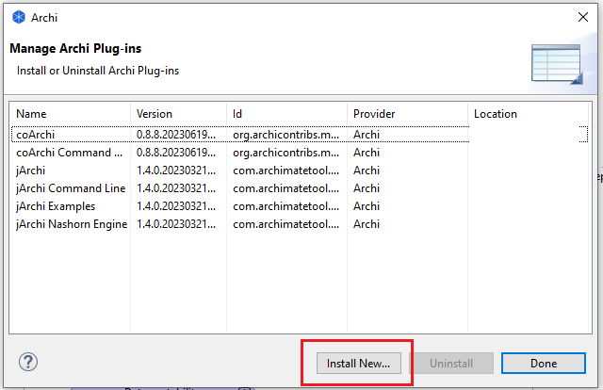

1. Select the downloaded CarTool installation file. It will have the ‘.archiplugin’ extension.
2. Wait until Archi asks you to reload and reload it.
3. After that, you will have the CarTool among the other Archi’s plugins and ready to use it.

A successful installation of the CarTool plug-in can be determined by the presence of a new menu named “EIRA”. This is the entry point for all CarTool features.



The next step is to ensure that your CarTool installation is updated with the latest version of its related Cartography data. The process required varies depending on whether you are a National or European Commission user. Both cases are subsequently described so that you can follow the section that applies to your case.

### Upgrading the CarTool for External to EC users

At this point, it is established that you are a user of Archi® and of the CarTool, and that you want to upgrade the CarTool.

1. Download the latest version of the CarTool file[[6]](#footnote-7).
2. Open Archi and go to the top menu: [Help] -> [Manage Plug-ins…]
3. Once the Plugings Manager is open, choose the ‘Cartography Tool Plugin’ and press [Uninstall]
4. Reload Archi…
5. Go to the top menu: [Help] -> [Manage Plug-ins…]
6. Once the Plugings Manager is open, choose [Install New…]



1. Select the downloaded CarTool installation file. It will have the ‘.archiplugin’ extension.
2. Wait until Archi asks you to reload and reload it.
3. After that, you will have the CarTool among the other Archi’s plugins and ready to use it.

A successful installation of the CarTool plug-in can be determined by the presence of a new menu named “EIRA”. This is the entry point for all CarTool features.

### The European Interoperability Cartography (EIC) for External to EC users

The **European Interoperability Cartography (EIC)**, as defined by the Decision (EU) 2015/2240 is a

*“repository of interoperability solutions for European public administrations provided by Union institutions and Member States, presented in a common format and complying with specific re-usability and interoperability criteria that can be represented on the EIRA”.*

The EIC Cartography has been included as a part of the CarTool and it comes by default through the installation of the CarTool plugin:

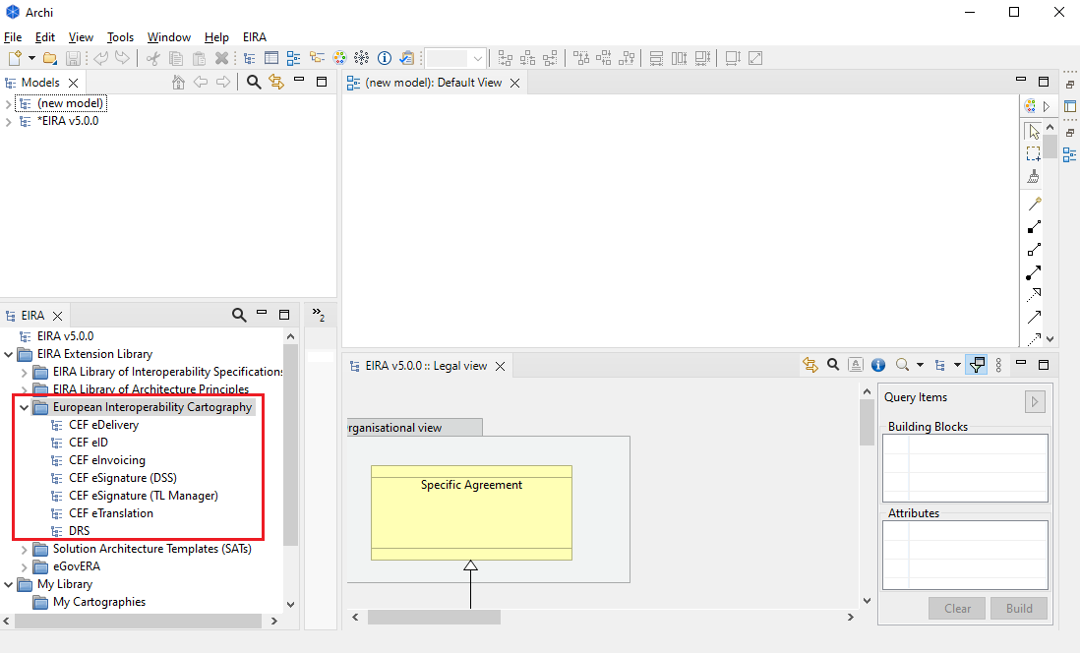

Click on the “European Interoperability Cartography” folder to have detailed information about the EIC v1.0.0 solutions.

## Getting started with the CarTool

To start using the CarTool select from the “EIRA” menu, option “Activate EIRA support”. This option ensures that the CarTool’s model overview and model details panels are opened.

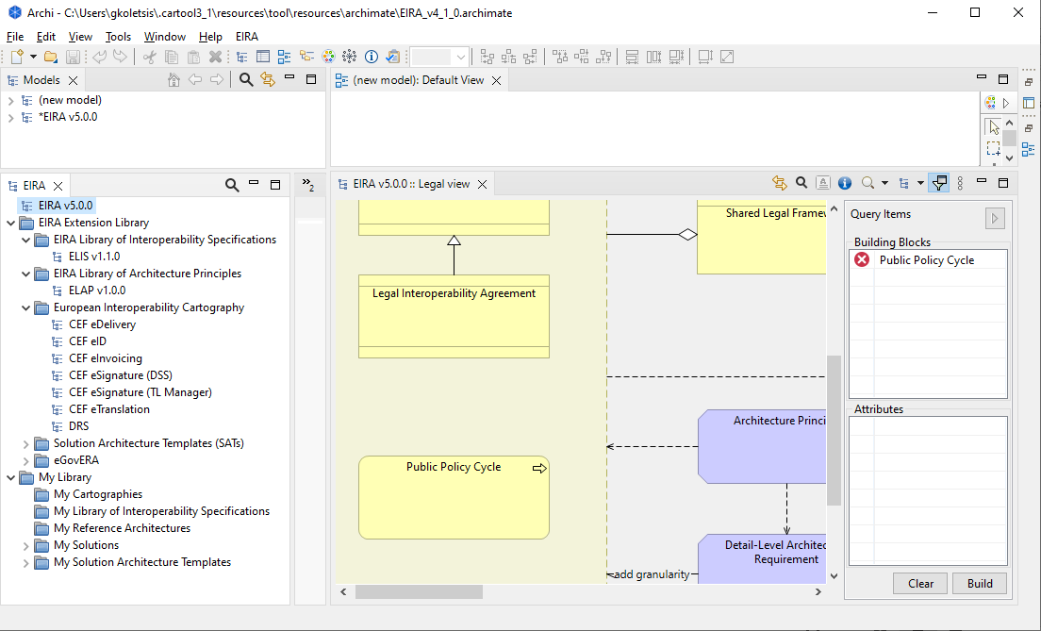

**CarTool** **Model**

**Details**

**CarTool**

**Model**

**Overview**

Note that the location where these panels open for the first time is not fixed. It is advised for a better experience, although not required, to drag and drop these panels so that they are positioned as displayed above (i.e. at the bottom left and bottom right respectively). This only needs to happen once, considering that the panels’ location is subsequently maintained.

## Updating the EIRA, the CarTool and the Cartography

Following your initial installation of the CarTool all updates to the EIRA, the CarTool as well as the Cartography data that it accesses are handled within the tool itself. Details on the update process are provided in Chapter 8, “Keeping the CarTool, Cartography copy and SATs up to date”.

## Updating Archi® for External to EC users

Updating your Archi® version is a process outside the control of the CarTool. Details on how to upgrade from a previous version are provided in the Archi® download page[[7]](#footnote-8) and could require you to uninstall your current version. In this case you will also have to reinstall the CarTool plug-in as described in this chapter although your downloaded Cartography data will remain unaffected.

Note that when upgrading Archi® to a version not explicitly marked as supported (see Chapter 2.1, “Installation prerequisites”) it is possible that you experience issues with the CarTool. In this case it would be advisable to install the new Archi® version at a separate installation path, install the CarTool on this new instance, and only if no problems are experienced, proceed to uninstall the previous version.

|  |
| --- |
| **IMPORTANT: The CarTool v6.0.0 plugin has been tested with Archi® versions from 4.9.0 to 5.1.0. This version plugin will not work with any version lower than 4.9.0. If you have an Archi® earlier version to 4.9.0, please upgrade to a newer version.** |
| **IMPORTANT: Archi® needs to be installed in a folder on which the user has write permission. The automatic update of the CarTool will fail if you do not have write permission.** |

## Removing the CarTool for External to EC users

To completely remove the CarTool and its data from your system and Archi® installation, carry out the following steps:

1. Open Archi and go to the top menu: [Help] -> [Manage Plug-ins…]
2. Once the Plugings Manager is open, choose the ‘Cartography Tool Plugin’ and press [Uninstall]
3. Reload Archi…
4. Upon restart of Archi® you will likely find placeholders for the previous CarTool panels containing errors due to the missing plug-in. Close them to complete the CarTool’s removal.

# Overview of features

The purpose of this chapter is to give you an overview of the features offered by the CarTool and introduce you to its graphical layout, panels and controls.

From a high-level perspective the CarTool enables you with the following features:

* **Inspect the EIRA’s views, ABBs and attributes**, including their documentation. This can be done both in graphical mode, by viewing the EIRA’s views, or in tabular form allowing searching and sorting.
* **Inspect the content of all Cartography solutions and SATs**. Similar to the EIRA this can be done both in graphical and tabular mode.
* **Create or modify solutions and SATs** (both Detailed-level Interoperability Requirement SAT and High-level Interoperability Requirements SAT) by adding to them SBBs (and also ABBs in the case of SATs), from the EIRA, SATs or other solutions.
* **Submit new and updated solutions and SATs** (both Detailed-level Interoperability Requirement SAT and High-level Interoperability Requirements SAT) for review and inclusion in the related Cartography.
* **Consult the ELIS (EIRA Library Interoperability of Specifications),** a library containing the standards and specifications defining the interoperability requirements of the architectural building blocks (ABBs).
* **Consult the ELAP (European Library of Architecture Principles)**, a library containing the architecture principles defining the guidelines for the design of interoperable digital public services.
* **Import of National Interoperability Specifications.** The imported catalogue of interoperability specification can be used to define the requirements of the architectural building blocks of your Solution or SAT.
* **Upload of national cartographies under “My Library” folder.** The imported national cartographies can be used as reference architecture to add building blocks into a new model as for the EIRAre.
* **Upload of national High-Level and Detail-Level Solution Architecture Templates (SATs).** The imported High-Level and Detail-Level SATs can be used reference SATs to add building blocks and solution building blocks into a new SAT as for the EIRA.
* **Consult proposed and used interoperability specifications** to find conformant SBBs from the Cartography and include them, and related specifications, to solutions and SATs.
* **Run complex queries on the Cartography’s solutions** with the possibility to save and share queries and export results. In addition, the CarTool now allows the possibility to build queries for each attribute of all the EIRA Building Blocks.

|  |  |
| --- | --- |
| exclamation-mark-310101_640 | Certain features mentioned above rely on the presence of a solution Cartography that is maintained and shared for CarTool users to access. At the time of writing such activities are possible within the European Commission but there is no governance process defined or supporting tooling for National Public Administrations. Such National CarTool users will thus not be able to make use of certain features, specifically:   * Inspecting the content of the Cartography’s solutions (see Chapter 4, “Inspecting the EIRA, the EIRA Extension Library and My Library”) * Submitting updates to solutions and SATs (see Chapter 5.7, “Submitting a TES or SAT update to the Cartography (European Commission only)”). * Consulting used interoperability specifications (see Chapter 6.3, “Viewing used interoperability specifications”) * Running complex queries on the Cartography (see Chapter 7, “Querying the Cartography”) |

## CarTool controls and panels

Archi® allows user interface panels, including those linked to the CarTool, to be placed in any way that best suits you. The following screenshot serves to highlight Archi®’s and the CarTool’s main controls, using the layout proposed in Chapter 2.3, “Installing the CarTool”, that should be suitable for most needs.

The table that follows describes each highlighted panel and control.

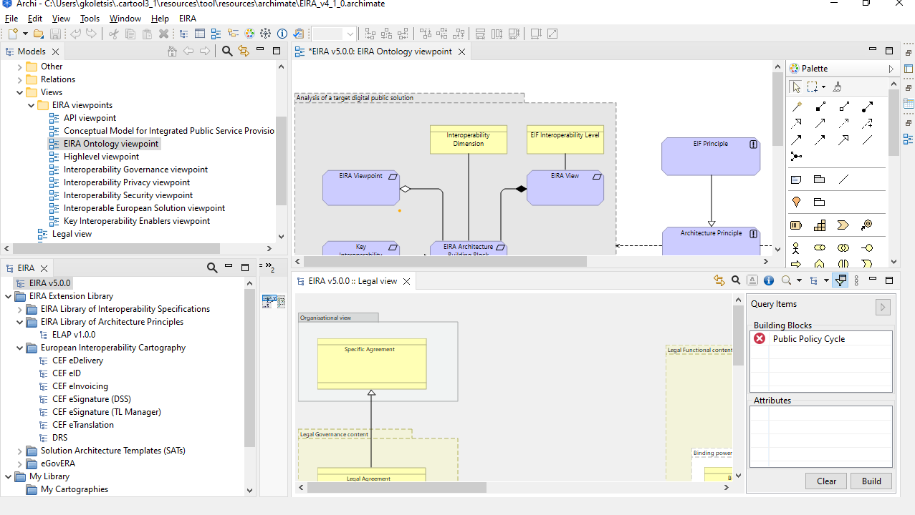

**5**

**8**

**3**

**1**

**6**

**7**

**9**

**2**

Table 3-1: Archi® and CarTool graphical elements and controls

| **Ref** | **Name** | **Description** |
| --- | --- | --- |
| 1 | Archi® menu bar | This is the main menu bar of Archi® through which all its features can be accessed. |
| 2 | EIRA menu | The EIRA menu that the CarTool plug-in introduces to Archi®. This menu offers the following options:   * **Activate EIRA support**: open the CarTool model overview and details’ panels. * **Manage Saved Queries**: Open up the saved query management screen. See Chapter 7.4, “Managing saved queries”, for details. * **Migrate Selected Models**: This will allow you to migrate EIRAv4.0.0 models to EIRAv4.1.0-🡪EIRAv5.0.0 * **Check for Updates…**: Check for updates to the tool or its Cartography data. * **About Cartography Tool**: Show the CarTool’s version and licensing information. See Chapter 8.1, “Viewing the CarTool version and licensing information”, for details. |
| 3 | Open models | This is the Archi® panel that displays the open models you are working with. You use this to inspect a model’s ArchiMate® elements and edit its views. |
| 4 | View editor | This is the panel in which you view and edit a model in Archi® for EIRA and non-EIRA related work alike. When using the CarTool to add SBBs and ABBs to solutions and SATs it will be done using this editor panel. See Chapter 5.2, “Adding building blocks to a solution or SAT”, for more details. |
| 5 | Palette | This is Archi®’s palette of ArchiMate® elements that you can add to the model currently open in the view editor. Note that these are “basic” ArchiMate® elements in that they don’t include any EIRA-specific metadata. You would use these however even when editing a model conforming to the EIRA if you are adding elements that do not exist as EIRA ABBs, or to associate elements. |
| 6 | CarTool model overview | This panel displays the EIRA, a folder “EIRA Extension Library” which includes the EIRA Library of Interoperability Specifications (ELISv1.1.0), the EIRA Library of Architecture Principles (ELAP v1.0.0), the European Interoperability Cartography(EIC), the SATs (High-level Interoperability Requirements SAT and Detailed-level Interoperability Requirements SAT) and the eGovERA. Moreover, it displays a folder “My library” which includes “My Cartographies”, “My Reference Architectures” and “My Solutions” which contains the TES Library (available only for EC users). In addition, ther “My Library” section contains the “My Cartographies” folder, the “My Library of Interoperability Specifications” folder and the “My Reference Architecture” folder where you can add your national cartographies, interoperability specifications and reference architectures.. From this panel you can inspect the EIRA, solutions or SATs, and you can create a new EIRA-conformant solution or SAT. |
| 7 | CarTool model details | This panel shows the details of the model you have selected in the CarTool model overview panel. This can be the EIRA, a solution, or an SAT, and can be displayed both in graphical (the default) and tabular mode where you see a listing of the building blocks and their attributes. This is the main panel you work with when adding EIRA ABBs and SBBs to the model you are currently editing, and also the place where you select items to build queries. See Chapter 4, “Inspecting the EIRA, the EIRA Extension Library and ” for further details. |
| 8 | CarTool model control bar | This toolbar provides the controls for the open CarTool model (the EIRA, or a selected solution or SAT). From here you can perform actions such as zooming, switching display mode from graphical to tabular, switching views, searching and viewing a view’s narrative. See Chapter 4, “Inspecting the EIRA, the EIRA Extension Library and ”, for more details. |
| 9 | Query item panel | This panel shows you at any given time the elements (building blocks and attributes) you have collected to run a query. From here you open the query builder dialog in which you can refine and subsequently execute your search. More information on this can be found in Chapter 7, “Querying the Cartography”. |

## Adapting the CarTool to suit your needs

It has been mentioned previously that the positioning of the CarTool and Archi® panels is something you can customise according to your needs. The current section presents potential ways of organising the panels to address two common use cases:

* Using the EIRA to model a solution.
* Using the EIRA to launch queries into the Cartography.

### Example 1: Focus on solution modelling

In this example the user’s main purpose is to use the CarTool in “editing mode” to create or modify a solution or SAT. The organisation of panels in this case is the one presented previously as the proposed way of working.



**2**

**1**

In this case, the top area (marked above with “1”) shows you the solution (or SAT) you are currently working with. Here you add elements to your model, arrange and associate them as needed, and switch between your model’s different views.

In the bottom area (marked as “2”) you have your EIRA reference. Here you can navigate the EIRA, as well as the solutions and SATs included in the Cartography, from which you pick ABBs or existing solutions’ SBBs to add as SBBs in your model. Notice in addition how the query item panel is minimised in this case to display a maximum of the EIRA for reference.

### Example 2: Focus on querying the Cartography

In this example the user’s main focus is on using the CarTool in “query mode”, searching through the Cartography to analyse solutions and produce reports.

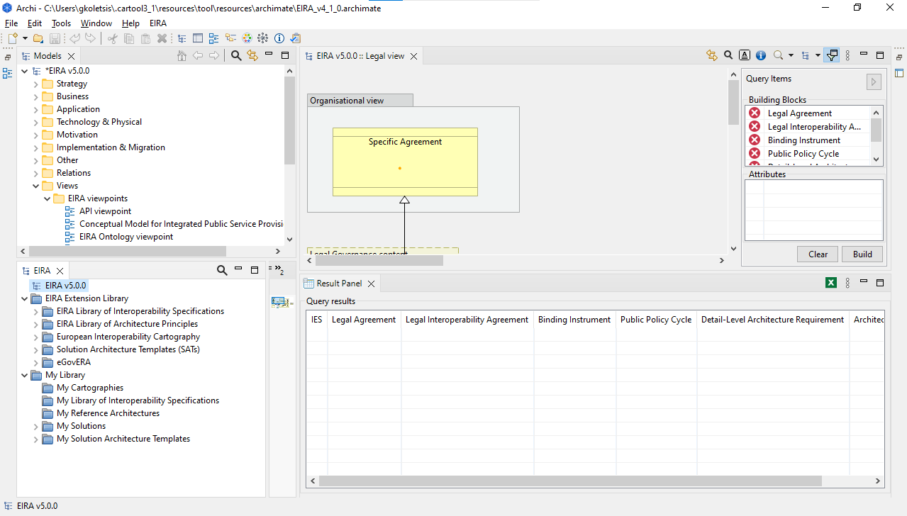

**2**

**1**

In this case the panels are arranged in a manner that puts searching at the forefront. The top area (marked with “1”) includes a maximised CarTool model detail panel, where the EIRA is opened and used to select building blocks for querying. In addition the query items’ panel is opened to continuously show you the items (building blocks and attributes) that you have added to your query.

The bottom area (marked with “2”) holds the query results’ panel. This panel is opened the first time a query is executed and is then refreshed with the latest query’s results. Notice in this arrangement how all other panels that are not directly linked to querying are minimised (e.g. the open models’ panel, or the view editor).

# Inspecting the EIRA, the EIRA Extension Library and My Library

This chapter goes into detail to explain the structure of the folders included in the CarTool plugin and how to use it to inspect the EIRA, as well as the Cartography, available SATs and TES Library.

## Structure of the CarTool

As depicted in the figure above, the CarTool is arranged into two different folders that includes the following components:

* **EIRA Library of Interoperability Specifications:** It includes the *ELIS (European Library of Interoperability Specifications).* Interoperability Specification ABB is a Business Object being embodied as a document of the highest possible level of granularity on an EIRA SBB, formulated as an agreed normative statement in design terms on a legal, organisational, semantic, or technical attribute of an European Public Service. It can refer to existing standards or specifications*.*
* **EIRA Library of Architecture Principles:** It includes the *ELAP* (*European Library of Architecture Principles*) Architecture Principle ABB is a Principle defining the underlying general rules and guidelines for the use and deployment of all IT resources and assets across the enterprise. They reflect a level of consensus among the various elements of the enterprise, and form the basis for making future IT decisions.
* **European Interoperability Cartography (EIC):** *European Interoperability Cartography* itself which is the repository of interoperability solutions for European public administrations provided by Union institutions and Member States, presented in a common format and complying with specific re-usability and interoperability criteria that can be represented on the EIRA.
* **Solution Architecture Templates (SATs):** a Solution Architecture Template (SAT) is a specification extending the EIRA providing support to solution architects in a specific solution domain. We can distinguish between Detailed-level Interoperability Requirements SAT and High-level Interoperability Requirements SAT.
* **eGovERA:** It includes the eGovERA Business Agnostic, eGovERA Tax, eGovERA Health Reference Architecture that can be used as a model to guide the development of digital public services (one or multiple in a specific policy area), starting from the needed organisational elements to be put in place, to base registries and systems to be developed or modernised.
* **My Cartographies:** local and national cartographies can be stored and consulted in the CarTool
* **My Library of Interoperability Specifications:** local and national interoperability specifications can be stored, consulted and added to a model.
* **My Reference Architectures:** reference architecturescan be stored in the CarTool and used for adding solution building blocks.
* **My High-Level Solution Architecture Templates:** national High-Level SATs can be stored in the CarTool and used for adding solution building blocks.
* **My Detail-Level Solution Architecture Templates:** national Detail-Level SATs can be stored in the CarTool and used for adding solution building blocks.

## Inspecting views and building blocks graphically

Your starting point in doing this is to select the EIRA (or a specific solution or SAT) from the CarTool model overview panel. Note that to view the available solutions and SATs you would need to expend the “IES” or “SATs” folder respectively. To open the EIRA, a solution, or an SAT, you can both double-click on it, or right-click on it and then select “Open”. The result will be to open up the CarTool model details’ panel, displaying the details of the EIRA (or the solution/SAT). To easier locate a specific solution, you can also use the search button (represented as a magnifying glass) that opens an in-place search box in which you can type the model’s name. As you type, the contents of the panel will continue to include the EIRA but will limit solutions and SATs to those including the typed text in their name. The search box can be collapsed by clicking again on the magnifying glass.

The default mode in which a model’s details are presented is graphical, i.e. displaying the model’s view diagrams. If the model does not contain any diagrams, i.e. it only contains the model’s elements, the tabular mode is opened up instead. Details on these two presentation modes are provided in the sections that follow.

The graphical display of the EIRA (or of a selected solution/SAT) displays the EIRA’s view diagrams, opening as default the high-level overview. Initially the query items’ panel is open but can be collapsed.

The open view shows its building blocks and their relationships. In the case of the EIRA, the building blocks displayed are the EIRA’s ABBs. If however it is a solution or SAT that is being viewed, the view will contain:

* In the case of a solution: the SBBs that it consists of as well as any other non-EIRA elements that were chosen to be modelled.
* In the case of an SAT: the ABBs as well as SBBs and non-EIRA elements that are modelled as part of it.

Although similar to how a model’s views are presented in Archi®, there is a key difference in that this view is read-only. Each building block however represents an active element that can be interacted with:

* Left-clicking a building block results in it being added to the current set of query items.
* Right-clicking a building block opens a context menu with further options:
  + **Documentation:** shows a popup with the building block’s documentation as defined in the EIRA. In the case this documentation has been adapted for a given solution or SAT, the adapted documentation is displayed. Note that a building block’s documentation also includes the documentation of its attributes.
  + **Online Documentation**: the documentation of building blocks can be also accessible PURIs (persistent unique identifier) on Joinup.

**5**

* + **Add to Model**: adds the building block to the model currently being edited as an SBB (enabled when the view editor is not empty).
  + **Add to Model as ABB**: When the user right clicks on a building block of the EIRA, (s)he can add a building block by clicking on 'Add to Model'.
  + **Update building block description**: the user can update the building block Description thanks to the new field “Documentation” added in the pop-up window displayed when the user adds a building block. The user can optionally change this description that will then be saved in the model.
  + **View available interoperability specifications**: displays available interoperability specifications for the selected building block.
  + **Add to Query**: adds the current building block to the set of query items.
  + **Add Attribute to Query**: opens a further menu showing the building block’s attributes. Selecting one of these adds it to the set of query items.

The “Add to Model” and “Add to Model as ABB” options are further discussed in Chapter 5.2, “Adding building blocks to a solution or SAT”. The “View available interoperability specifications” option is discussed in Chapter 6.2, “Viewing available interoperability specifications”, whereas “Add to Query” and “Add Attribute to Query” are discussed in Chapter 7.1, “Selecting query items”.

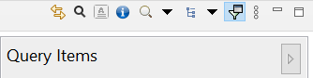To the top-right of this panel you can access the panels’ additional controls. These controls are displayed when in graphical or tabular mode (described in the next section) but are enabled as appropriate.

**4**

**8**

**7**

**6**

**5**

**3**

**9**

**2**

**1**

*1*

*9*

*6*

*5*

*8*

*7*

*4*

*3*

*2*

The following table explains each control’s purpose

Table 4-1: The CarTool model control bar

| **Ref** | **Description** | **Graphical mode?** | **Tabular mode?** |
| --- | --- | --- | --- |
| 1 | Search to find a specific building block or attribute. This opens an in-place search box that can be closed when clicking again on the search button. Starting to type text in the search box will automatically switch to the tabular mode to present matched results. Note that the search text can also be cleared by clicking on its “x” icon at its far right side. | "V" mark | "V" mark |
| 2 | Switch the presentation to tabular mode. If already in tabular mode, this control allows switching back to graphical mode (and is displayed with an appropriate icon). | "V" mark | "V" mark |
| 3 | Show a popup with the view’s narrative (if one is present). | "V" mark | "X" mark |
| 4 | Zoom in and out of the current view, with the possibility to also restore the zoom to its actual size. Note that this can also be achieved by additional shortcuts:   * Holding control and using the mouse wheel. * Holding control and tapping “+” or “-”. | "V" mark | "X" mark |
| 5 | Switch between the different views. | "V" mark | "X" mark |
| 6 | Show or hide the query items’ panel. | "V" mark | "V" mark |
| 7 | Generic Archi® controls to maximise, minimise and show available controls. | "V" mark | "V" mark |
| 8 | Similar to “6”, this shows or hides the query items’ panel. | "V" mark | "V" mark |
| 9 | Link view is a toggle button which will open the corresponding EIRA-View. | "V" mark | "X" mark |

## Inspecting views and building blocks in tabular form

The tabular display of the EIRA (or a selected solution/SAT) shows a listing of its building blocks and attributes in tables, which allow searching and ordering to quickly find elements of interest. The applicable controls of the CarTool model control bar are the same as in the case of the graphical mode, described in the previous section.

Both building block and attribute tables support right-clicking to bring up a context menu of possible actions. For the case of building blocks, the possible options are the same as in graphical mode, as described in the previous section when right-clicking on a building block’s element. Regarding the attributes’ table, right-clicking allows a more limited set of actions as follows:

* **Documentation**: shows a popup with the attribute’s documentation.
* **Add to Query**: adds the selected attribute to the current set of query items.

The content of the tables shown in the tabular display differ depending on whether you are inspecting the EIRA, a solution or an SAT. In addition, when searching, the search text entered is differently applied. Regardless however of their specificities, all tables allow sorting to help find elements. The way in which the information is presented, its meaning and the behaviour of search filtering are described in the following three sections.

### Table contents when inspecting the EIRA

When inspecting the EIRA, you see the following two tables (and columns):

* **Architecture Building Blocks**: Lists the ABBs of the EIRA.
  + **View**: The view this ABB belongs to.
  + **Name**: The ABB’s name.
* **Attributes**:
  + **View**: The view of the ABB this attribute belongs to.
  + **Architecture Building Block**: The ABB this attribute belongs to.
  + **Name**: The attribute’s name.

Concerning searching, the entered search text is applied in a case-insensitive manner as follows (per table):

* **Architecture Building Blocks**: matches the name of the ABB.
* **Attributes**: matches the attribute’s name or ABB name.

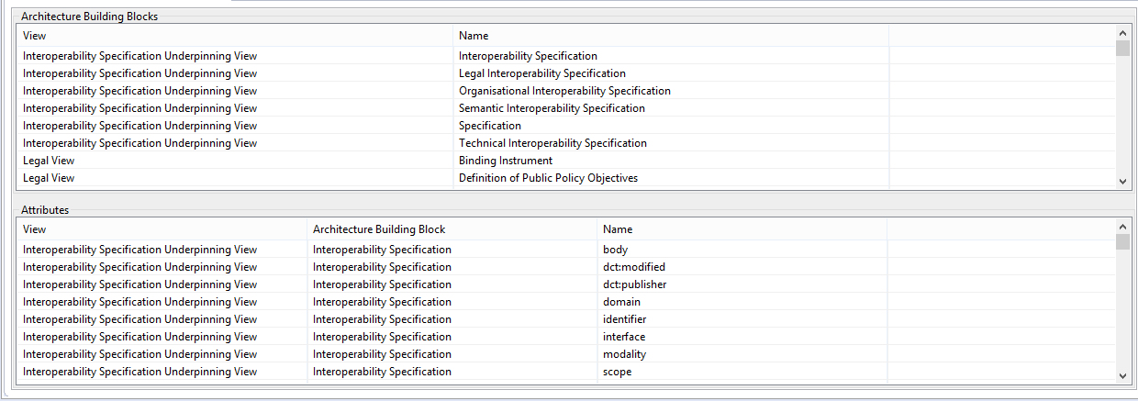

### Table contents when inspecting EIC (European Interoperability Cartography) solutions.

When inspecting a **solution**, the tables displayed contain the following content:

* **Solution Building Blocks**: Lists the SBBs included in the solution.
  + **View**: The view this SBB belongs to.
  + **Architecture Building Block**: The ABB this SBB corresponds to.
  + **Name**: The SBB’s name.
* **Attributes**: Lists the attributes of the solution’s SBBs.
  + **View**: The view of the SBB this attribute belongs to.
  + **Architecture Building Block**: The ABB that corresponds to the SBB of this attribute.
  + **Solution Building Block**: The name of the SBB this attribute belongs to.
  + **Name**: The attribute’s name.
  + **Value**: The attribute’s value.

In this case entering a search text this is applied in a case-insensitive manner as follows (per table):

* **Solution Building Blocks**: matches the ABB type or SBB name.
* **Attributes**: matches the ABB type, SBB name, attribute name or attribute value.

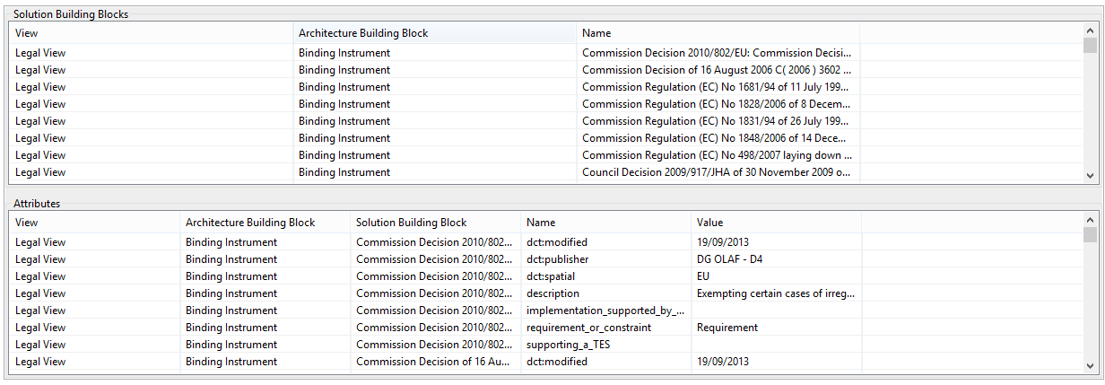

### Table contents when inspecting an SAT

When inspecting an SAT both Detailed-level and High-level SAT the tables’ content is as follows:

* **Building Blocks**: Lists the SAT’s ABBs and SBBs.
  + **View**: The view this ABB or SBB belongs to.
  + **Building Block Type**: The type of building block. In case this is an ABB, the text “ABB” is displayed. In case of an SBB, the text “SBB” is displayed, followed by the name of the related ABB.
  + **Name**: The name of the ABB or SBB.
* **Attributes**: Lists the attributes of the SAT’s ABBs and SBBs.
  + **View**: The view to which the attribute’s ABB or SBB belongs to.
  + **Building Block Type**: The type of the attribute’s building block (as in the case of the “Building Blocks” table).
  + **Building Block Name**: The name of the attribute’s ABB or SBB.
  + **Name**: The attribute’s name.
  + **Value**: The attribute’s value.

In this case entering a search text is applied in a case-insensitive manner as follows (per table):

* **Solution Building Blocks**: matches the ABB type or SBB name.
* **Attributes**: matches the ABB type, building block name, attribute name or attribute value.

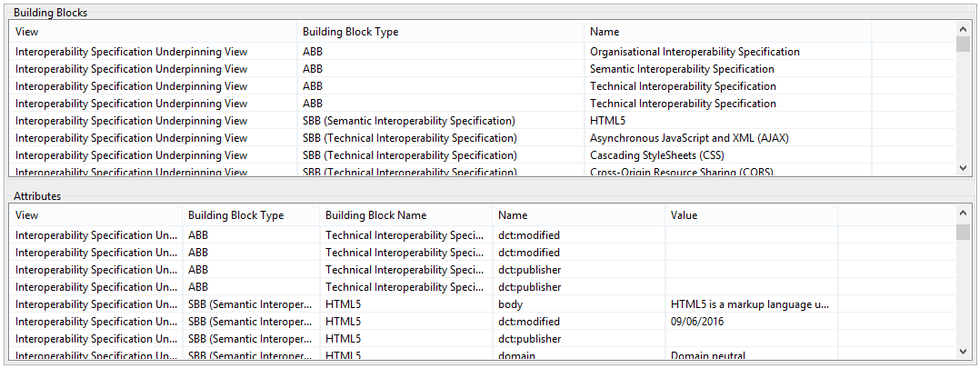

### Online Documentation

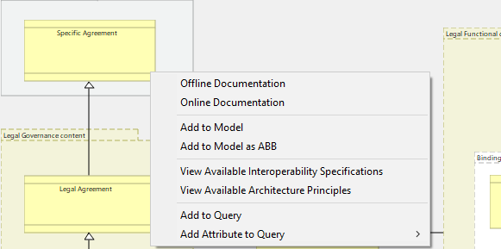As mentioned in the section “4.2 Inspecting views and building blocks graphically”, an important feature of the CarTool is the possibility to consult the online documentation of building blocks in Joinup through PURIs (Persistent Unique Identifier). By right-clicking on a building block you can select the “Online Documentation” functionality from the menu.

Hereunder it is displayed an example of the building blocks online documentation on Joinup:

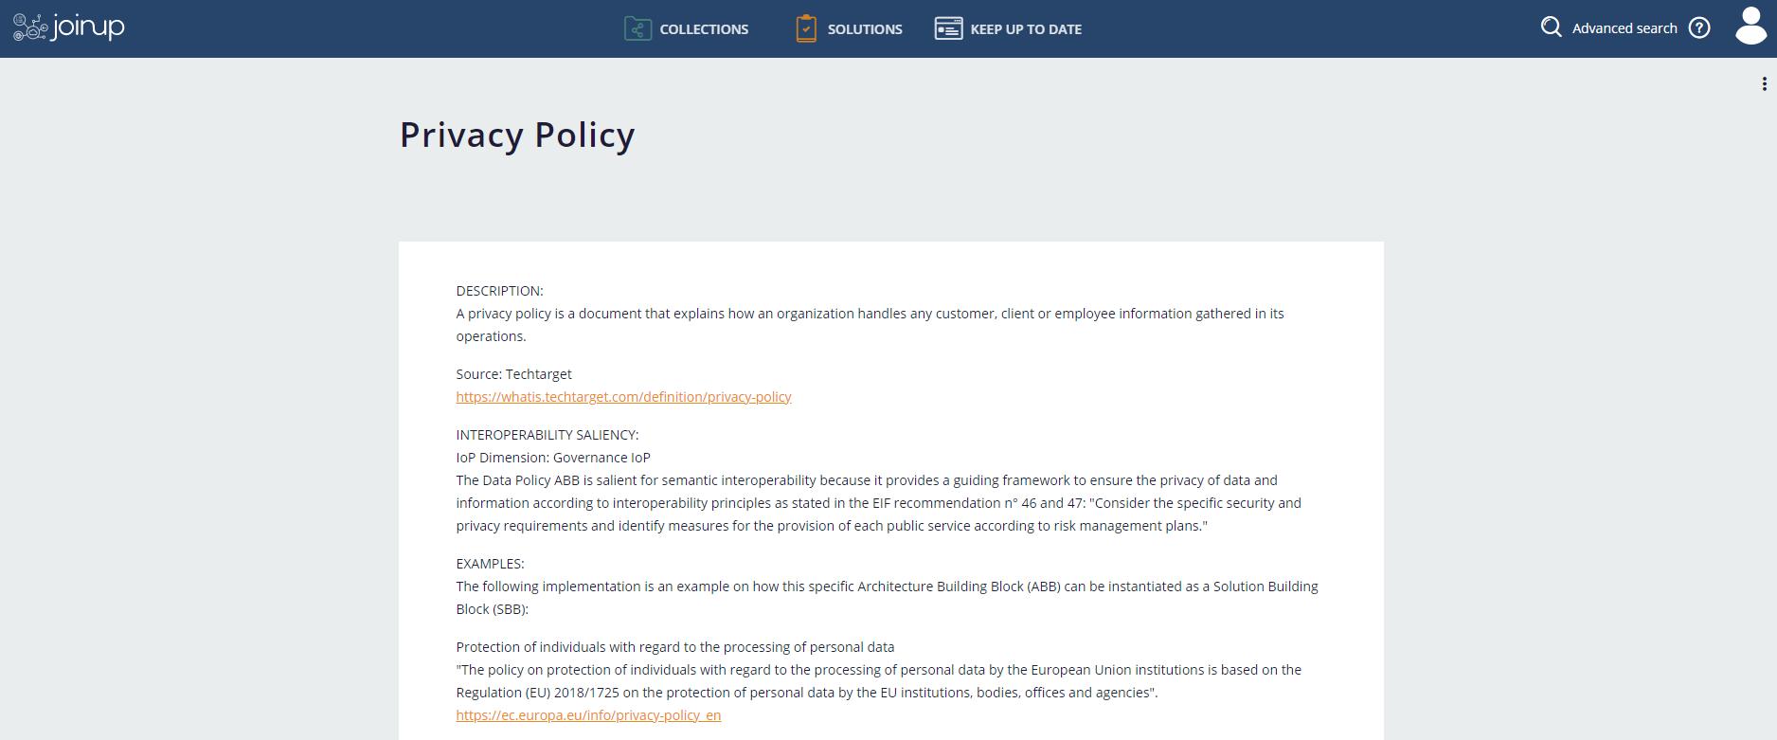

*1*

**ABB**

**DOCUMENTATION**

*2*

* **ABB documentation:** here it is displayed the documentation of the building block aligned with the EIRA;
* **ABB “neighbours”:** ABB “neighbours” include all the building blocks that are linked to the selected building block.

# Creating and updating solutions or SATs

One of the CarTool’s primary use cases is to allow architects to model their solutions in conformance to the EIRA. The CarTool supports you in this by:

* Allowing you to easily access the EIRA, other solutions and SATs for reference.
* Automating as much as possible the entry of metadata and expected attributes.
* Helping you reuse as much as possible through auto-completion based on existing Cartography solutions.

It is important to note that, in terms of solution modelling, the CarTool acts as a complement, and not a replacement, to the features offered by Archi®. A typical workflow, including features offered by both the CarTool and Archi®, would include the following steps:

1. [CarTool feature] Create a new solution (or SAT). This will add the required EIRA metadata for your solution and get you started based on an existing model template.
2. [CarTool feature] Add EIRA SBBs to your solution’s views, using the CarTool to access the EIRA, solutions, and SATs. This will automate input as much as possible and help you complete the information expected for each building block.
3. [Archi® feature] Use Archi®’s modelling palette to associate building blocks and potentially add other ArchiMate® elements to your model.
4. [Archi® feature] Update your model’s EIRA and non-EIRA building blocks by accessing their properties.

The sections that follow explain in detail how you can achieve these steps.

## Creating a new solution or SAT

The first step in creating a new solution or SAT is to right-click on the EIRA entry in the CarTool model overview panel. You will see a context menu that includes the options:

* 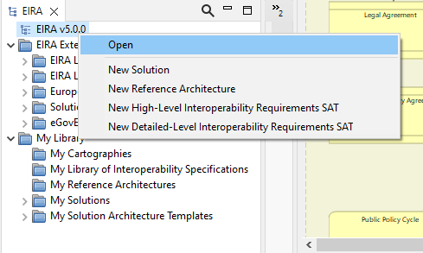New Solution
* New Reference Architecture
* New High-level Interoperability Requirements SAT
* New Detailed-level Interoperability Requirements SAT

Pick the option that corresponds to the model type you want to create. When selecting to create a new SAT you will simply get prompted with the location to which you want to save your model. In case you are creating a solution however, you will first be prompted with a dialog to enter a first set of key attributes.

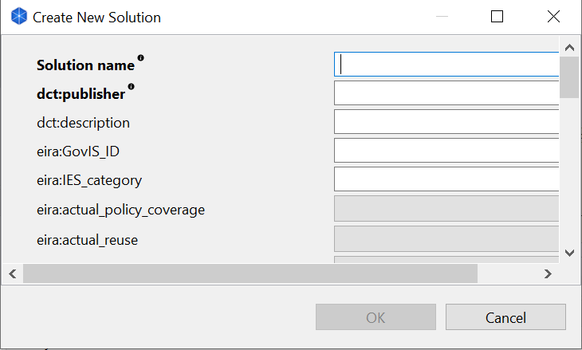

Hovering your mouse pointer over the “i” icon next to each attribute’s label will display a tooltip to explain the attribute’s meaning. The values you enter will be stored as attributes (using the displayed names) of the solution’s model. Mandatory attributes are marked in bold and consist of:

* **Solution name**: The name of the solution you are modelling.
* **dct:publisher**: The name of the person, party or organisation that is providing the information. This can be your name or e.g. the title of your organisational unit. Picking an appropriate value for this is important as this is recorded by default in all subsequently added SBBs, as the provider of the information (but can be modified if appropriate).

Once you have provided this initial information you will be prompted to pick a location to save your new model.

The result in both cases (new solution or new SAT) is that you have a new model created for you in Archi®’s open models’ panel containing:

* ArchiMate® views created for each EIRA view that are currently empty of building blocks.
* An introductory note in each view explaining the view’s purpose. This is for your initial information and should be subsequently deleted. To view this text again you can always refer to the corresponding view’s narrative in the CarTool model details’ panel when in graphical mode as described in Chapter 4.2, “Inspecting views and building blocks graphically”.
* (In case of a solution) The information you entered in the first dialog recorded as attributes of the model.

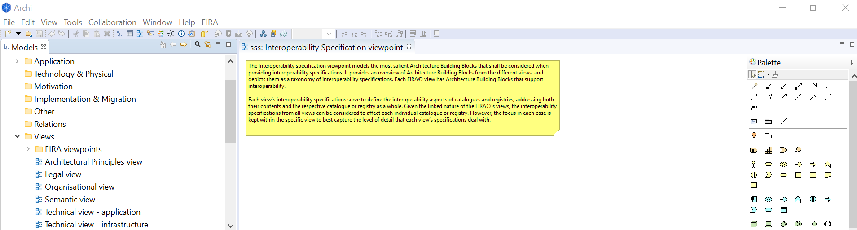

The next step is to proceed in adding building blocks to your new model.

## Adding building blocks to a solution or SAT

Building blocks represent the key elements that make up your solution or SAT. EIRA building blocks are modelled as ArchiMate® elements with certain points to consider:

* ABBs include a set of attributes to store metadata (e.g. date modelled) and data (e.g. reusability information). These attributes are defined as ArchiMate® element properties.
* When an ABB is selected for addition to a solution’s model it becomes an SBB, i.e. a specific instance of the ABB. In terms of modelling, SBBs differ from ABBs in that:
  + The properties corresponding to the ABB’s attributes are populated with appropriate values (automatically or manually).
* When an ABB is selected for addition to an SAT it can be added either as an ABB or as an SBB. Adding it as an ABB highlights this as an important element for solutions that are based on the SAT, for which a solution will need to find an appropriate[[8]](#footnote-9) SBB. On the other hand, adding it as an SBB highlights this as a required element of target solutions.
* The user can add an ABB or SBB by clicking on “Add to Model”. Moreover, the user can update the building block description thanks to the new field “Description” added in the pop-up. The user can optionally change this description that will then be saved in the model. Regardless of whether you are adding a SBB or ABB to a solution or SAT respectively, make sure you place it in the appropriate EIRA view for your model.

To add a SBB (based on an ABB) to your solution or SAT, follow these steps:

1. Open the EIRA (or an SAT) from the CarTool model overview panel.
2. Make sure that in the view editor you have opened the view to which you want to add the SBB. Select your view by double-clicking it from your model in the open models’ panel so that it is opened in the view editor.
3. In the CarTool model details panel, either in graphical or tabular mode, locate the ABB you wish to add.
4. Right-click on the ABB and select “Add to Model” (note that there needs to be an open view editor to enable this). Notice how the cursor changes at this point to show that it is ready to place the new SBB.
5. Find the location on your view (in the view editor) where you want to add the SBB and left-click.
6. Complete the name for the SBB and the attributes as requested through the dialog that opens up. Regarding the SBB name, the only required input marked as such in bold, typing will suggest matching SBB entries from the Cartography. You can either select one of these (by left-clicking or selecting using the up and down arrow keys and pressing enter), or define your own name.
7. the user can update the building block Description thanks to the new field “Documentation” added in the pop-up. The user can optionally change this description that will then be saved in the model.

1. Clicking “OK” will result in the new SBB being placed in your view and model.

To better illustrate this process, the above steps are also illustrated in the screenshot that follows (using the graphical display mode of the EIRA to locate the ABB):

*[1] Select EIRA*

*[3-4] Find ABB to add*

*[7] SBB added*

*[5-6] Complete SBB name and attributes*

*[2] Open your solution’s view*

Apart from adding an SBB to your solution or SAT based on one of the EIRA’s ABBs, you also have the following possibilities:

* **Add an existing SBB to your solution or SAT**: If you are using another solution or an SAT as your reference it could be the case that you want to include in your model one of its existing SBBs. In this case when right-clicking on the SBB (in graphical or tabular mode) and selecting to “Add to Model”, the same dialog to provide the name and attributes will open but will be prefilled with the SBB’s information for you to confirm.
* **Add an ABB to your SAT**: If you are in the process of modelling an SAT you will want to include ABBs from the EIRA that will remain as ABBs, for solutions to specialise. In this case, and only if the active view editor corresponds to an SAT, you will also have the option to “Add to Model as ABB”. In this case the ABB is simply copied as-is from the EIRA without prompting for a name or attribute values.
* **Add a non-EIRA** **building block to your solution or SAT**: In case a solution or SAT includes elements that are not EIRA-related (i.e. “simple” ArchiMate® elements) you can still choose to add these to your model. Selecting “Add to Model” in this case will copy the building block as-is to your model without further prompts.

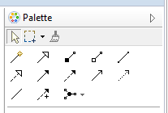Once you have added one or more building blocks to your model your next task will be to **model their relationships**. The EIRA guides you in this by representing the relationships between its ABBs which are especially important for SATs where relationships between modelled ABBs are expected to match those in the EIRA. Regarding SBBs however, in solutions or SATs, relationships can be modelled more freely to e.g. represent specific relationships that are in force. The CarTool does not provide additional tools for modelling relationships; this is achieved using the base Archi® modelling features to associate building blocks, notably the palette (displayed here). The palette can also be used to add new ArchiMate® elements that are not related to the EIRA.

### Avoiding building block duplication

Each EIRA view has certain focal ABBs that represent the links between its views. For example the Public Policy ABB links the Legal View to the Organisational View, thus providing the required regulatory context to a solution’s organisational elements. When modelling your solution it is typically interesting to include SBBs corresponding to such ABBs in multiple views to provide richer information and model specific relationships. In such cases it is important to not add multiple times the same ABB from the EIRA or to copy and paste it from the view you are editing. The correct approach to reference multiple times the same building block, similar actually to any element from an ArchiMate® model, would be to select it from Archi®’s model overview panel and then drag and drop it on the desired view.

## Adding Building Blocks to a Solution or SAT from an imported Reference Architecture

This new version of the CarTool provides the possibility to use imported Reference Architectures to model your Solutions or SATs.

To import a Reference Architecture in the CarTool, in the EIRA menu option, right-click on “My Reference Architectures” under the folder “My Library”, a pop-up window will give you the possibility to import any Reference Architecture. Please refer to the image below for a deeper understanding:

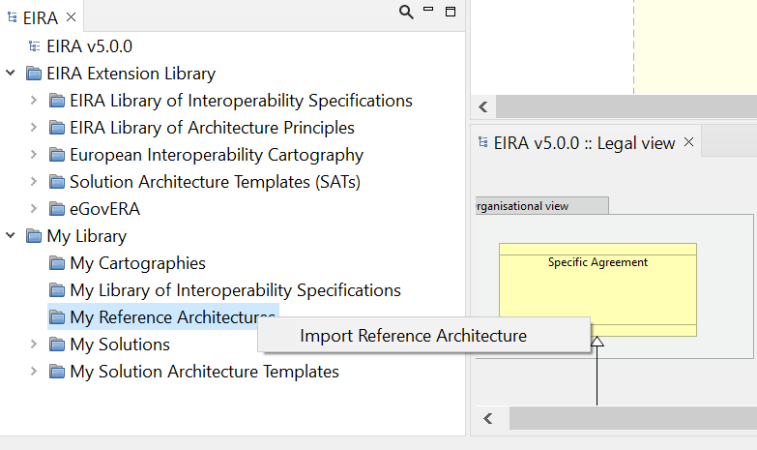By clicking on “Import Reference Architecture”, you will be able to search in your local repository the reference architecture you want to upload. The imported "architecture" shall be expressed in the Archimate format to be readable by the CarTool.

Once uploaded, the CarTool provides you with the possibility visualise the new Reference Architecture and to use it to create a new Solution based on the imported Reference Architecture by right-clicking in in the reference architecture and select “New Solution” (please refer to the image below).

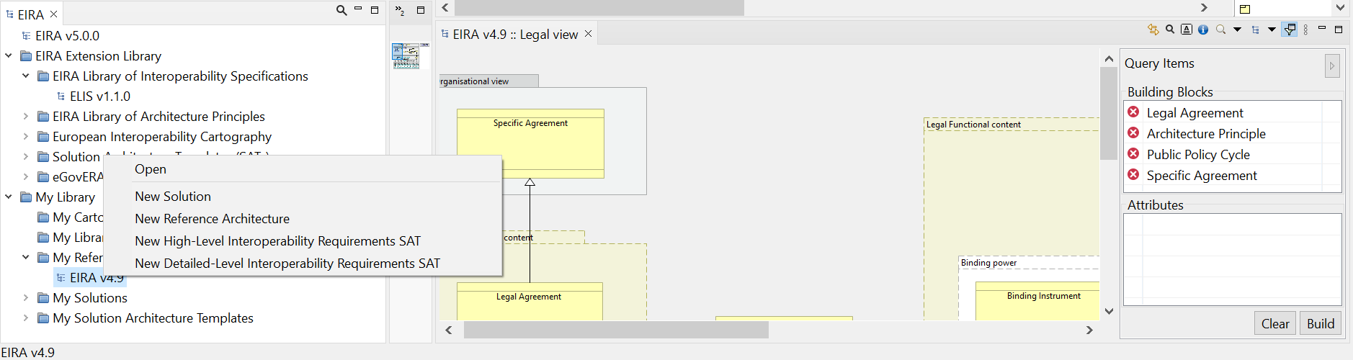

In addition, instead of creating a new Solution, it is possible to add a building block into your EIRA base or blank model following the below described procedure:

1. Open the imported Reference Architecture, placed under the “My Reference Architecture Folder” in the CarTool model overview panel.
2. Make sure that in the view editor you have opened the view to which you want to add the SBB. Select your view by double-clicking it from your model in the open models’ panel so that it is opened in the view editor.
3. In the imported Reference Architecture model details panel, either in graphical or tabular mode, locate the ABB you wish to add.
4. Right-click on the ABB and select “Add to Model” (note that there needs to be an open view editor to enable this) if you want to add the ABB as SBB. Notice how the cursor changes at this point to show that it is ready to place the new SBB.

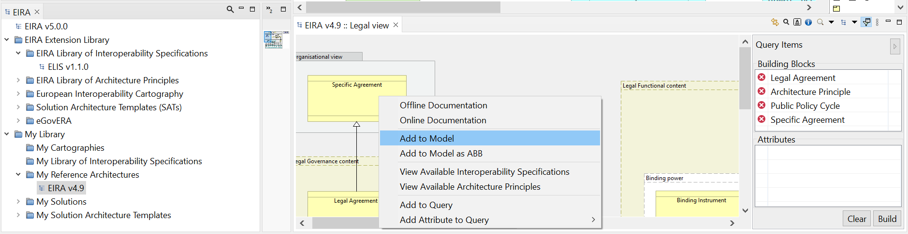

1. Find the location on your view (in the view editor) where you want to add the SBB and left-click.
2. Complete the name for the SBB.

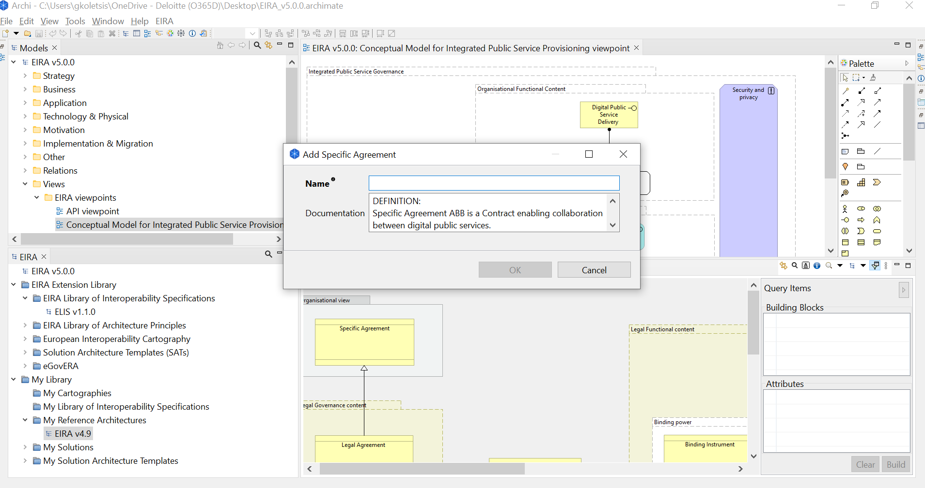

Once the SBB will be instantiated in the new model, the SBB will have a property indicating the ABB that is instantiating. The property will be available in the section “properties” as “eira:ABB”. Here, the SBB will include the same element as EIRA’s ABBs have in the property “dct:type”.

## Adding Building Blocks to a Solution or SAT from an imported High-Level or Detail-Level SAT

This new version of the CarTool provides the possibility to use imported High-Level and Detailed-Level Solution Architecture Templates to model your Solutions or SATs.

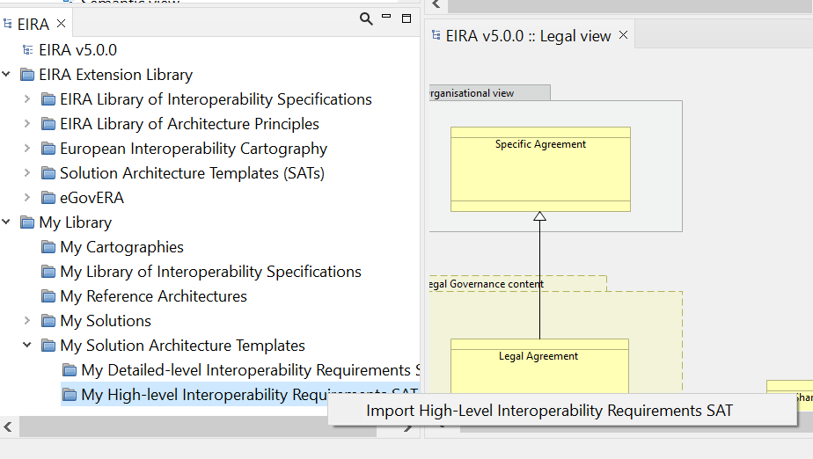To import a High-Level and Detailed-Level SAT in the CarTool, in the EIRA menu option, expand the folder “My Solution Architecture templates” and right-click on “My Detailed-Level interoperability Requirements SAT” to import a Detailed-Level SAT or on “My High-level Interoperability Requirement SAT” to import a High-Level SAT. A pop-up window will give you the possibility to import any SAT. Please refer to the image below for a deeper understanding:

By clicking on “Import High-level/Detailed-level Interoperability Requirements SAT”, you will be able to search in your local repository the SAT you want to upload. The imported SAT shall be expressed in the Archimate format to be readable by the CarTool.

Once uploaded, the CarTool provides you with the possibility visualise the new SAT and to use it to instantiate new ABBs or SBBs in a new solution or SAT, as explained below.

It is possible to add a building block into your EIRA base or blank model following the below described procedure:

1. Open the imported SAT, placed under either the “My High-level Interoperability Requirement SAT” or “My Detailed-Level interoperability Requirements SAT” in the CarTool model overview panel.
2. Make sure that in the view editor you have opened the view to which you want to add the SBB or ABB. Select your view by double-clicking it from your model in the open models’ panel so that it is opened in the view editor.
3. In the imported SAT model details panel, either in graphical or tabular mode, locate the ABB or SBB you wish to add.
4. Right-click on the ABB or SBB and select “Add to Model” or “Add to Model as ABB”, depending on the type of model you are creating, (note that there needs to be an open view editor to enable this). Notice how the cursor changes at this point to show that it is ready to place the new SBB or ABB.

**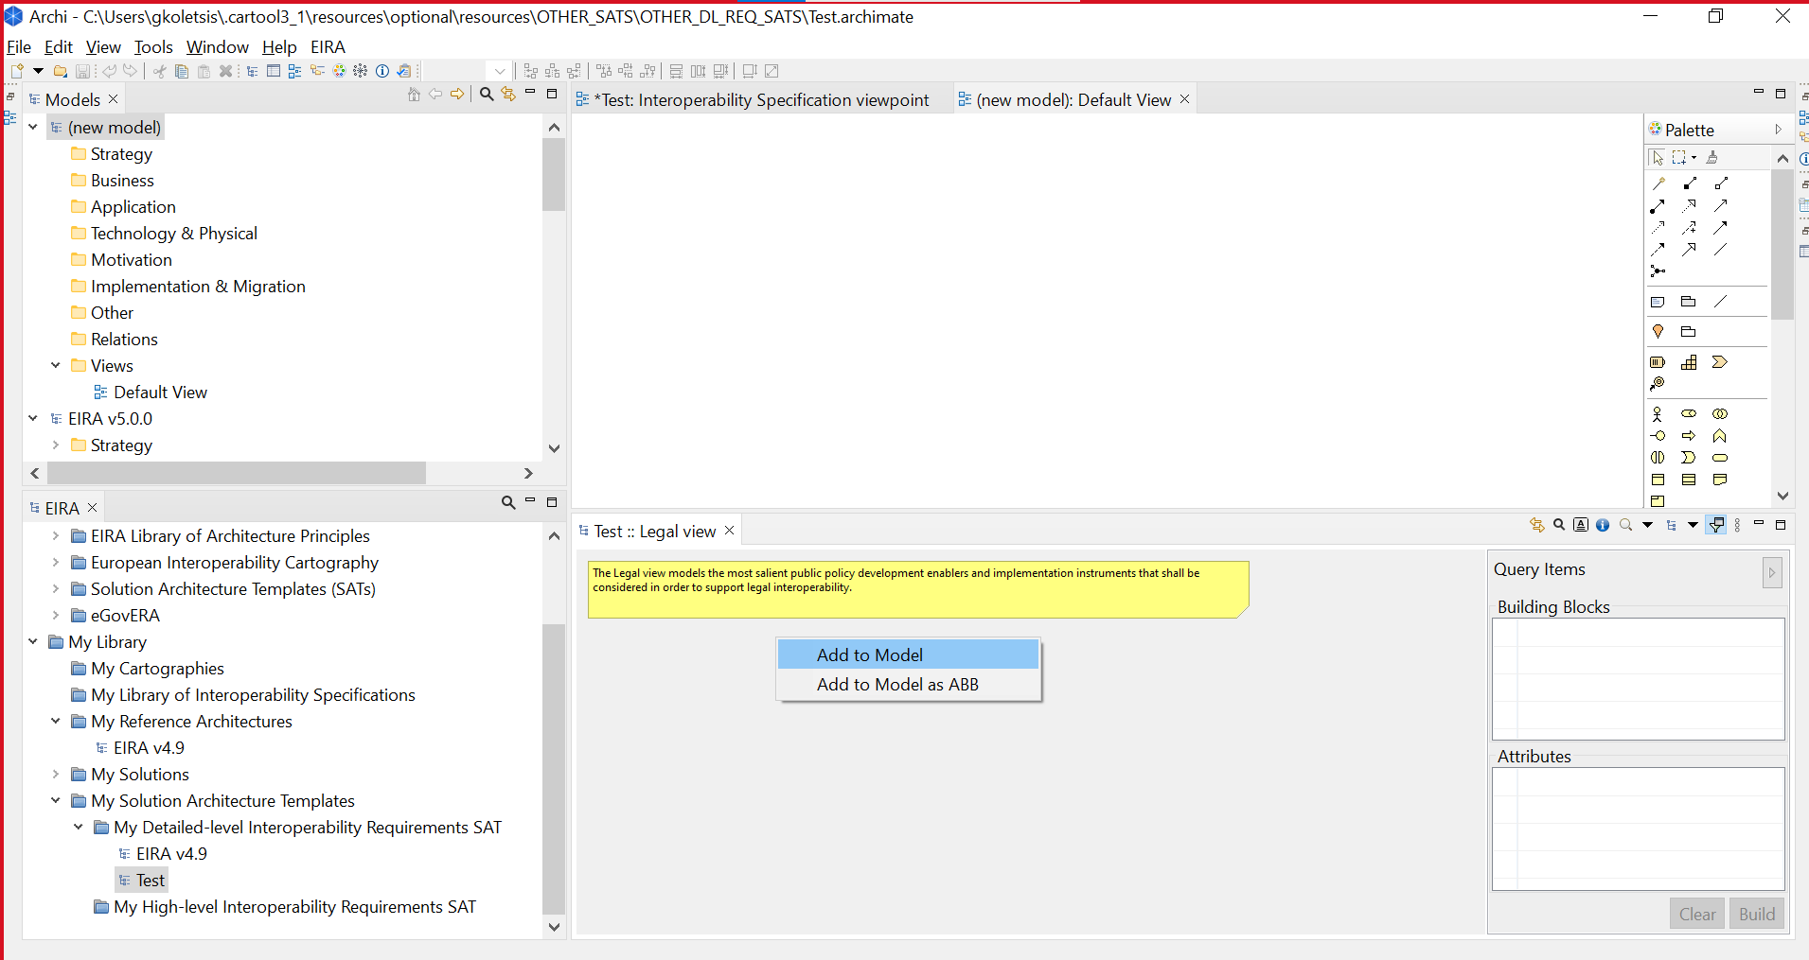**

1. Find the location on your view (in the view editor) where you want to add the SBB or ABB and left-click.

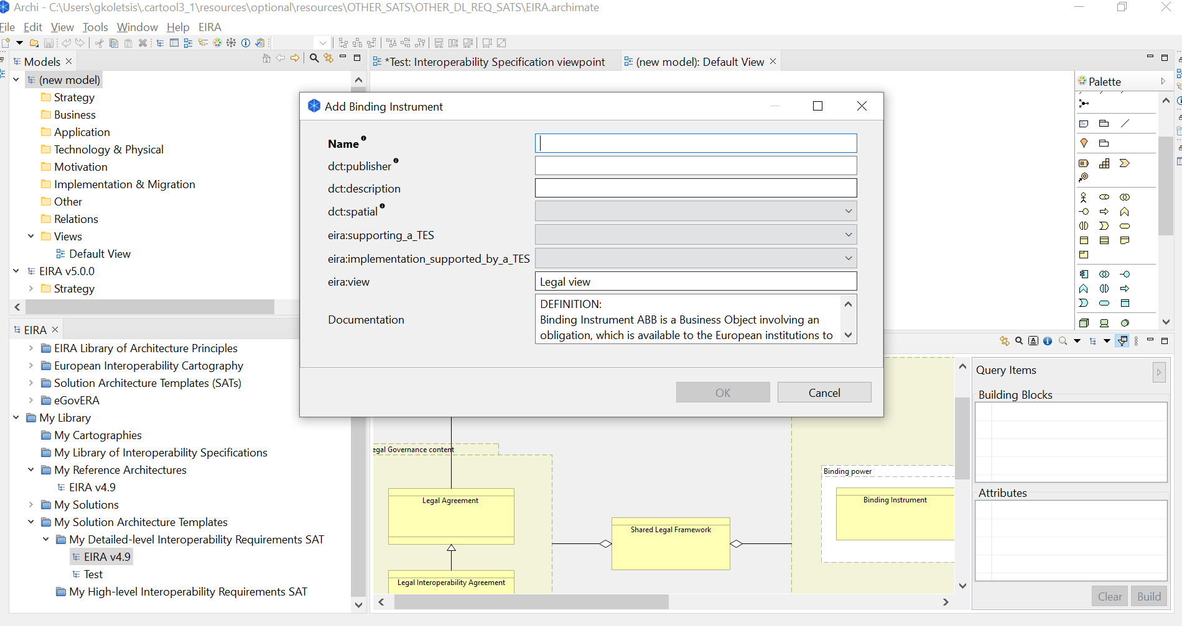12. In case of SBBs, complete the name for the SBB.

Once the SBB will be instantiated in the new model, the SBB will have a property indicating the ABB that is instantiating. The property will be available in the section “properties” as “eira:ABB”. Here, the SBB will include the same element as EIRA’s ABBs have in the property “dct:type”.

## Updating a solution or SAT’s building blocks

Once a building block has been added to your solution or SAT there is (currently) no additional advanced support in editing or viewing its attributes and metadata. To do this you would follow the approach used for any ArchiMate® element, by using Archi®’s property editor.

The property editor, or simply properties’ panel, is not open by default. To display it select from the Archi® menu bar “Window” and then “Properties”. As in the case with all Archi® and CarTool panels, this panel can be placed at any location that best suits your needs.

When selecting the SBB that you want to update, the content of the properties’ panel includes the following tabs:

* **Main**: Includes the name of the SBB and its documentation (if present).
* **Properties**: Includes the list of the SBB’s attributes and their values.
* **Analysis**: Shows you the views in which this SBB is included and the relations to other elements.
* **Appearance**: Allows you to customise the shape, colour and font for the SBB’s display.
* **Label**
* **Figure**
* **Image**

Of these tabs, the most important is the “Properties” tab in which you can edit individual properties. Note that all properties are treated as text values for which you need to manually enter the appropriate value(s). You are not presented in this case with controls such as single and multiple selection lists enumerating accepted values, but rather need to input values as simple text.

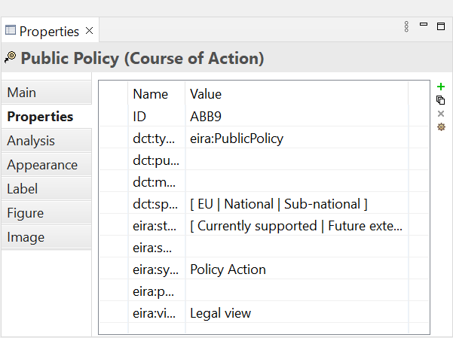

Regarding the name of the SBB, this can be edited both by entering the new value in the “Main” tab of the properties’ panel or by simply double-clicking the SBB’s element in the view editor.

## Updating a solution or SAT from the Cartography

The solutions and SATs listed in the CarTool model overview panel are read-only and serve for reference purposes. If you want to make an update to one of these you need to:

1. Find the desired solution or SAT.
2. Right-click its entry in the model overview panel and select “Edit”.
3. In the file explorer that appears, select the location to which you want to save a copy of the solution or SAT.

Once saved on your file system you can proceed to update the solution or SAT in the same way as any other Archi® model.

## Submitting a TES or SAT update to the Cartography (European Commission only)

Once you complete your modelling, either by creating a new TES solution or SAT, or by updating an existing one, you will want to publish your changes in the Cartography. You need to keep in mind that the Cartography data you access with the CarTool is a local, read-only copy, and that changes made are also local and not shared with other CarTool and Cartography users. Cartography and SAT updates need to be submitted for review and validation, and only then get integrated into a subsequent Cartography version. The updated Cartography version, once published, will be automatically synchronised to users’ CarTool instances, using the features described in Chapter 8, “Keeping the CarTool, Cartography copy and SATs up to date”.

To submit a new or updated model for publishing in the Cartography, you need to:

1. Select your model, either by left-clicking it from the open models’ panel, or by focusing (via left-click) on one of the model’s open views in the view editor.
2. Select from the Archi® menu bar “File”, then “Export”, and finally “Model to Open Exchange File…”.
3. In the dialog that pops up, enter the target location for the export and, optionally, select to “Include Folder Organisation”. There is no need to “Copy XSD schema file to target location” or to select a different “Language”.
4. Click on “Save”.

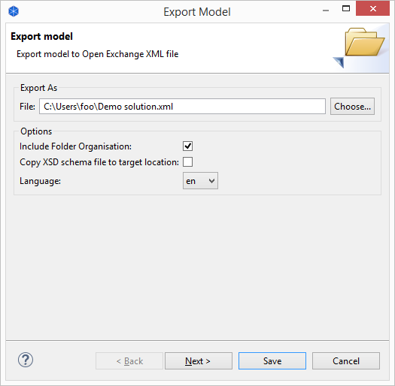

1. Email the exported model file to [DIGIT-EIRA@ec.europa.eu](mailto:DIGIT-EIRA@ec.europa.eu). To facilitate subsequent analysis please mention briefly in this email the high-level changes your update includes.

By following these steps you have submitted your solution’s ArchiMate® model in the Open Group’s Model Exchange Format, the standard means of exchanging ArchiMate® content. By using this format, other users, which do not necessarily use the CarTool can also submit Cartography modifications. Upon validation, a new version of the Cartography will be made available that you will be able to use in the CarTool following your next update.

# Accessing interoperability specifications

An important feature of the CarTool is to help you in identifying the interoperability specifications to base your solution or SAT on. Interoperability specifications serve as requirements for interoperability that are linked to specific ABBs, either in a cross-domain or domain-specific manner. Simply put, an ABB defines the features and functionalities that you need at an abstract level, for which you can find an appropriate specific SBB based on the interoperability specifications that it conforms to.

The CarTool provides support with respect to interoperability specifications helping you to:

* Consult the *ELIS (European Library of Interoperability Specifications)*, the library containing the standards and specifications defining the interoperability requirements of the architectural building blocks (ABBs)
* Find interoperability specifications that are proposed for a given ABB, potentially in a specific domain.
* Find interoperability specifications that are actually in use within the Cartography.
* Find SBBs from within the Cartography that conform to a given interoperability specification.

These features are discussed in the sections that follow.

## Consult the European Library of Interoperability Specifications

The EIRA Library of Interoperability Specifications is a library containing the standards and specifications defining the interoperability requirements of the architectural building blocks (ABBs) contained in the European Interoperability Reference Architecture (EIRA). The aim of this library is supporting solutions architects when modelling using EIRA.

The ELIS displays the following elements:

* **Architecture Building Block:** EIRA ABBs linked to the interoperability specifications;
* **Specification name:** The specific name of the interoperability specification that serve as requirements for interoperability that are linked to specific EIRA ABBs;
* **Domain:** the specific domain associated to the interoperability specification;
* **Type:** shows if the specification is a standard, an application profile, a family of specifications or simply a specification according to the CSSV;
* **URL:** The URLs of the interoperability specification.
* **Assessment:** provides the title of the assessment performed by the CAMSS team if any;
* **Assessment landing page:** link to the assessment in Joinup for its consultation.

## Consult the European Library of Architecture Principles

The EIRA Library of Architecture Principles is a library containing the architecture principles defining the guidelines for designing interoperable digital public services. The aim of this library is supporting solutions architects when modelling using EIRA.

The ELAP displays the following elements:

* **Category:** the type of architecture principle;
* **Scope:** the Policy Domain to which the architecture principle belongs to;
* **Principle name:** the name of the architecture principle;
* **Statement:** describes the fundamentals of the principle;
* **Rationale:** highlight the business benefits of adhering to the principle. Defined using business terminology;
* **Implications:** highlight the business benefits of adhering to the principle. Defined using business terminology
* **Interoperability Layer (IoP Layer):**
* **Principle Source:** name and basic information of the source for the architecture principles;
* **URL:** The URL to the principle source or basis
* **About source:** context information for the source of architecture principles;
* **PURI:** the Persistent URI for each principle;

## Viewing available interoperability specifications

To view the complete list of proposed interoperability specifications select option “available interoperability specifications” from the EIRA menu. This will open up the results’ display panel listing all proposed interoperability specifications per EIRA view, ABB and policy domain (if applicable). Through this listing you can inspect information on the specification such as their name, persistent URI and documentation URL. To facilitate inspection, you may also rearrange the table’s columns, sort per column, or export the results in Microsoft Excel format.

Each specification listed in the table supports right-clicking to bring up a context menu with the following options:

* **Add Interoperability Specification to Model**: Selecting this will prompt you to add the specification as a SBB in your currently active model’s view.
* **Find Implementing Solution Building Blocks**: Triggers a search in the Cartography to find SBBs for the related ABB that conform to the selected specification. These are presented in the results’ panel and, through right-click and by selecting “Add Solution Building Block to Model” can be added as a SBB to your currently open model.

In both cases, when either adding an interoperability specification to your model, or when adding a SBB that implements it, you will be prompted with a dialog to confirm the SBB and its attributes before addition.

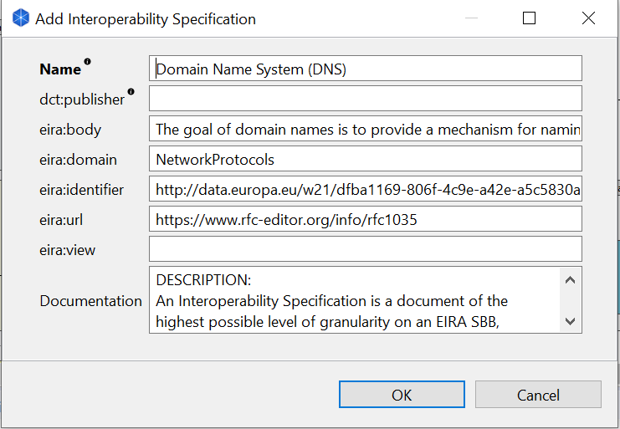

An alternate way of viewing proposed specifications is not to start from their complete listing as described previously but to start from an ABB or SBB. To do this:

1. Open the EIRA or any other model (solution or SAT) in the CarTool model details’ panel.
2. Either in graphical or tabular mode, right-click on an ABB or SBB and select “Propose Interoperability specifications”.

You will now be presented in the results’ panel with the proposed interoperability specifications that apply to the ABB you selected.

## Viewing used interoperability specifications

The feature of viewing used interoperability specification is very similar in terms of supporting functionality as that described in the previous section for proposed specifications. In this case the difference is that you can view the specifications that have actually been used as SBBs in the Cartography, which may or may not be part of the list of proposed specifications.

To view the list of used specifications, select from the EIRA menu option “Interoperability Specifications in Use”. The contents of the results’ panel will now be completed with the specifications found as SBBs in the Cartography. From this point on, all options are similar to those of proposed specifications in that:

* Specifications can be added as SBBs to your current model.
* SBBs can be located in the Cartography that implement selected specifications and be added themselves to your model.

## Viewing Available Architecture Principles

To view the complete list of proposed interoperability specifications select option “View Available Architecture Principles ” (Figure 1.1) from the EIRA menu. This will open up the results’ display panel listing all proposed architecture principles per EIRA view, name, body, scope and policy domain (if applicable) (Figure 1.2). Through this listing you can inspect information on the specification such as their principle, definition of the principle, domain, category, source and about source documentation. To facilitate inspection, you may also rearrange the table’s columns, sort per column, or export the results in Microsoft Excel format.

Each specification listed in the table supports right-clicking to bring up a context menu with the following option:

* **Add Architecture Principle to Model:** Selecting this will prompt you to add the specification as a SBB in your currently active model’s view.(Figure 1.4)

When adding an Architecture Principle to your model, you will be prompted with a dialog to confirm the SBB and its attributes before addition.(Figure 1.3)

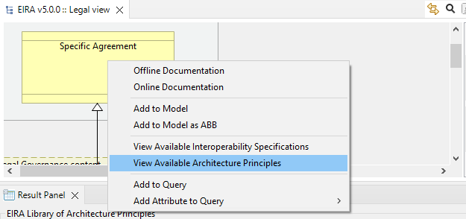

Figure 1.1

Figure 1.2

Figure 1.3

Figure 1.4

An alternate way of viewing proposed principles is not to start from their complete listing as described previously but to start from an ABB or SBB. To do this:

1. Open the EIRA or any other model (solution or SAT) in the CarTool model details’ panel.
2. Either in graphical or tabular mode, right-click on an ABB or SBB and select “Add Architecture Principle to Model”.

You will now be presented in the results’ panel with Add Architecture Principle to Model that apply to the ABB you selected.

## Import of National Interoperability Specifications

The CarTool provides a new feature which enables the user to import National Inteorperabilty Specifications or any other specification needed to be used by the user.

To import Interoperability Specifications, in the EIRA menu option, right-click on “My library of Interoperability Specifications” under the folder “My Library”, a pop-up window will give you the possibility to import national interoperability specification to the CarTool. Please refer to the image below for a deeper understanding:

By clicking on “Import Interoperability Specifications”, you will be able to search in your local repository the catalogue of interoperability specification you want to upload. The imported "catalogue" of Interoperability specifications shall be expressed in the same format of the "ELIS specifications" under the "EIRA Library of Interoperability Specifications".

Once uploaded, the CarTool provides you with the possibility to select and add the imported Interoperability specifications into a new model (Solution or a SAT). Specifically, when right-clicking on a selected Interoperability Specification, you will visualize the option "Add Interoperability Specification" to the model (Solution or SAT).

# Querying the Cartography

Aside from modelling solutions and SATs, the CarTool offers you a second key use case: running queries on the solutions’ Cartography data.

The overall approach to querying in the CarTool is as follows:

1. Use the EIRA, as well as solutions and SATs to collect building blocks and attributes to include in your query.
2. Once you have selected the query items you want, open the query builder to tune them by specifying reporting columns and filtering criteria.
3. Run the query and view the matching SBBs and attributes in the results’ panel.
4. Export to excel in case further analysis is required (e.g. organisation in pivot tables).
5. Save queries that you expect to be frequently using.

These steps are discussed in detail in the sections that follow.

## Selecting query items

Query items are the elements that form a given query, either as information to be displayed in the query results, or as filtering criteria with which to limit results. They are collected from the EIRA, or from a specific solution or SAT that you would like to refer to. Selecting the EIRA or solution you want to inspect is the subject of Chapter 4, “Inspecting the EIRA, the EIRA Extension Library and ”.

Once you have the EIRA (or a solution/SAT) open in the CarTool model details’ panel, you can add items to your current query both using the graphical and tabular display mode. Specifically:

* **Graphical mode**:
  + Add a **building block** by left-clicking it, or by right-clicking and selecting “Add to Query”.
  + Add an **attribute** by right-clicking the building block, selecting “Add Attribute to Query” and then selecting the specific attribute you wish.
* **Tabular mode**:
  + Add a **building block** by right-clicking in its row in the building blocks’ table and selecting “Add to Query”.
  + Add an **attribute** either by right-clicking on a building block row, selecting “Add Attribute to Query” and then selecting the attribute, or by right-clicking in a row in the attributes’ table and selecting “Add to Query”.

Depending on whether you are collecting query items from the EIRA, an SAT or a solution, the behaviour of adding a query item differs based on the nature of the selected building block. The following table summarises what happens in each case.

Table 7-1: Items you can add to a query

|  |  |  |
| --- | --- | --- |
| **Item to add** | **Source** | **Resulting query item** |
| ABB | EIRA or SAT | The ABB is added to the set of building blocks to query with. |
| ABB attribute | EIRA or SAT | The attribute is added to the set of attributes to query with. |
| SBB | Solution or SAT | The SBB’s ABB is added to the set of building blocks to query with. The specific SBB itself is added as a filter value. |
| SBB attribute | Solution or SAT | The attribute is added to the set of attributes to query with. The specific attribute value in the SBB is added as a filter value. |
| Non EIRA building block | Solution or SAT | N/A (the option is disabled). |
| Non EIRA attribute | Solution or SAT | N/A (the option is disabled). |

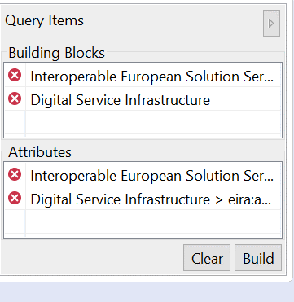

The set of currently selected building blocks and attributes appear in the query item panel. Building blocks appear with the ABB name, whereas attributes are displayed using their name and their ABB’s name. Note that all building blocks and attributes selected are unique.

*1*

*3*

*6*

The query item panel allows you to do the following:

* View the ABBs [1] and attributes [2] currently selected.

*2*

* Remove an ABB or attribute from the query [3].

*5*

* Clear all query items [4].

*4*

* Proceed to build the query using the selected query items [5].
* Hide (or show) the query item panel [6].

Once you have selected the ABBs and attributes to include in your query, the next step is to build the query by defining its details.

## Building the query

Selecting to build a query opens up the query builder dialog. The purpose of this dialog is to refine the selected query items (ABBs and attributes) by defining:

* Which of the items will be included in the results as report columns.
* Which of the items will be used as search criteria to filter returned values.
* For filter items, which values are to be considered for the filtering.

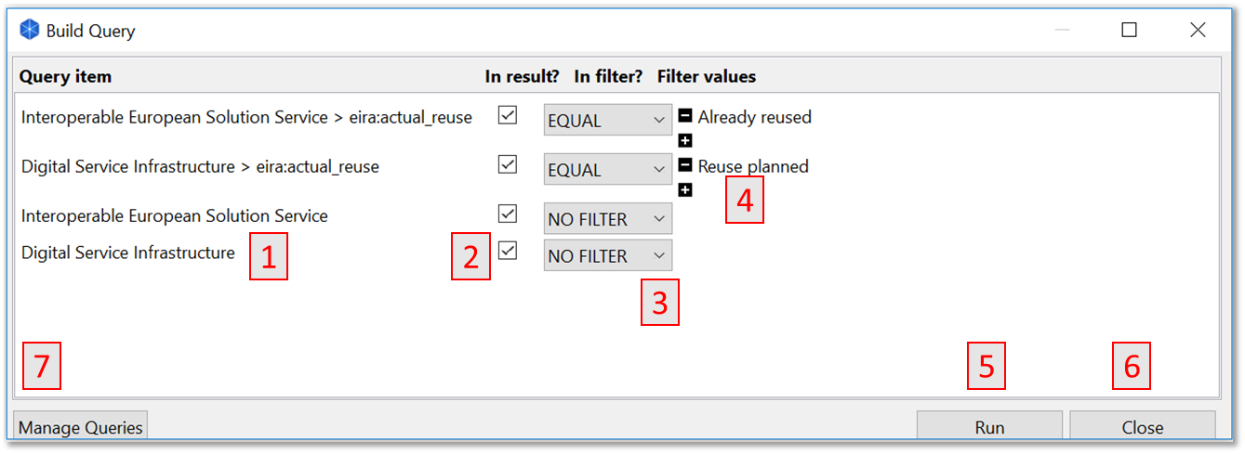

The selected items’ names appear in the left of the dialog [1] as rows, presenting one checkbox and a combo box, allowing choosing whether you want to include it in the results [2] or add filter criteria [3]. In case one of the values (different to “NO FILTER”) in the combo box is selected, the user is prompted to include a value for the filter item that is proposed, as you type, from the existing Cartography SBBs (for a query item that is an ABB), or from the list of accepted values (for an attribute query item). Additional filter values can be added for an item by clicking “+”, and existing ones removed by clicking “-”. In terms of filtering semantics:

* Each separate query item set as a filter is applied with “and” semantics.
* The different values for a single query item set as a filter are applied with “or” semantics.

Once the query is defined according to your needs, you can:

* Run the query to view its results [5].
* Close the query builder dialog [6] without running the query. Note that the state of your query is not lost in this case, allowing you to collect additional query items and return to continue where you stopped.
* Access query management features [7], described in Chapter 7.4, “Managing saved queries”.

## Running the query

Once your query is built according to your needs, the next step is to run it and inspect its results. This is achieved by clicking the “Run” button from the query builder dialog.

The query results are displayed in the results’ panel that is automatically opened, if previously closed, and brought into focus. As with all Archi® and CarTool panels, the results’ panel can be freely positioned using drag and drop and resized according to your preferences. The panel displays as columns the selected query items that have been marked as part of the result, including, in the first column, the name of the corresponding solution. All columns are sortable in ascending or descending manner by clicking on their header and can be repositioned using drag and drop. In addition, note that accessing other panels and using other controls will not clear the panel’s results; this is only done if you close the panel or run a new query.

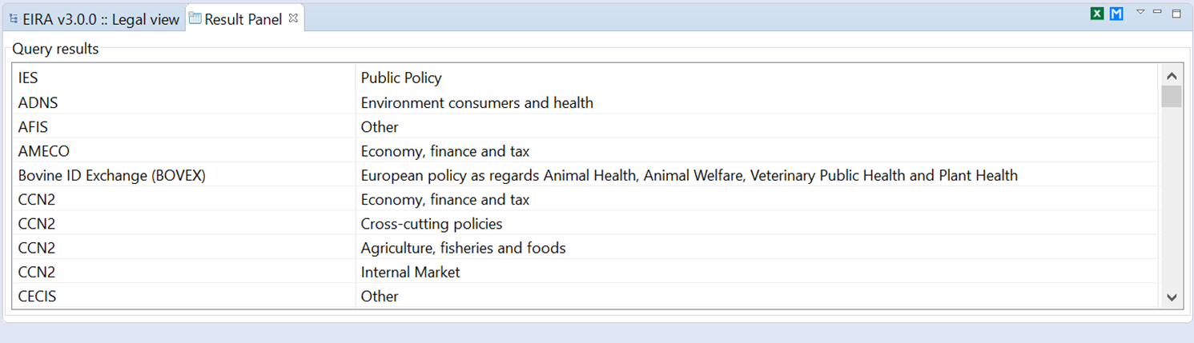

*1*

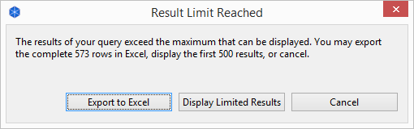The results’ panel includes a button in the top-right corner [1] that allows you to export the result set in Microsoft Excel. You may want to do this to keep a copy of the results or use Excel’s features to gain further insight into the data, for example through data filtering and pivot tables. An export to Excel is automatically proposed as well when running a query if its results are too numerous to be displayed within the results’ panel. In such a case you are prompted with the following options:

* **Export to Excel**: To directly prompt you to save the results as an Excel file.
* **Display Limited Results**: To truncate the results and show the limited result set in the results’ panel.
* **Cancel**: To cancel the query’s execution.

It is important to understand that a large number of results can be frequently achieved due to the nature of the underlying data. If you select multiple ABBs for your query, these will be expanded as a Cartesian product for the different values to achieve a row-based report without loss of information, and to allow consistent data manipulation through Excel. To better deal with large result sets, the current best approach is to filter appropriately and potentially use Excel’s advanced functions for further analysis.

## Managing saved queries

To facilitate searching and to streamline your work, the CarTool offers a set of useful management capabilities over the queries you build. It allows you to save queries and share them with others, tasks that could be very useful in the following cases:

* You want to **repeat complex queries** and avoid the time needed to define them from scratch.
* You want to **share ready-to-use queries** with other CarTool users.
* You want to **build variations of existing queries** without redefining their common elements.

Such tasks can be achieved through the query builder dialog, with query management features enabled. You can do this in two ways:

* Through the EIRA menu, by selecting option “Manage Saved Queries”.
* Through the query builder itself, by clicking the “Manage Queries” button.

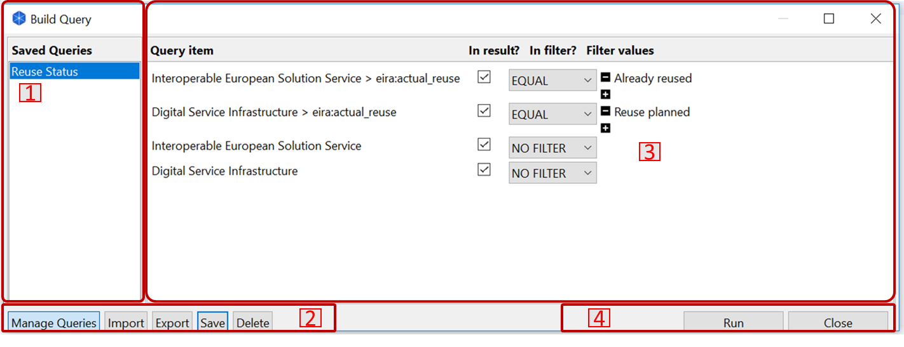

When query management is enabled, the query builder includes the following sections:

* The saved query list (marked as “1”), originally empty, shows your saved queries, with the active one (if any) marked as highlighted. Clicking on individual queries refreshes the query details panel. Note that multiple queries can be selected at once by holding control or shift when clicking.
* The query details panel (marked as “2”) is the main panel of the query builder that is always visible, showing you the elements of the selected saved query, or of the query that is currently being built.
* The query management controls (marked as “3”) allow you to do the following:
  + **Manage Queries**, to hide or show the query management features. The button is indicated as active or inactive to better illustrate this.
  + **Import**, to import one or more queries from your file system.
  + **Export**, to export one or more selected queries to a location of your file system.
  + **Save**, to save the current query. You are always prompted for the query name to allow you to potentially change it and effectively make a copy of the query.
  + **Delete**: Delete one or more selected queries.
* The basic query controls (marked as “4”) allowing you to run the current query or close the query builder dialog. Note that if you close the query builder dialog and reopen it, it will display the query management features and the saved query you had open. You can use this approach to update saved queries by adding more items to them from the EIRA.

# Keeping the CarTool, Cartography copy and SATs up to date

The update process of the CarTool is designed to stay as much as possible out of your way. The process addresses both the tool itself as well as your local copy of the Cartography data and can be triggered in two ways:

* Automatically, whenever you restart Archi®.
* Manually, as explained in Chapter 2.3

In both cases the prerequisite to a successful update check is to have a working internet connection. Note that this is the only situation when you need a connection; working with the CarTool otherwise takes place is a fully offline manner.

|  |
| --- |
| **IMPORTANT: Archi® needs to be installed in a folder on which the user has write permission. The automatic update of the CarTool will fail if you do not have write permission!** |

|  |
| --- |
| **IMPORTANT: If you are behind a proxy, you can set the URL and the port in the local-config.properties file. This file is located within the “.cartool6\_0” folder, a subdirectory under the Archi’s “plugins” folder.** |

## Viewing the CarTool version and licensing information

To view the CarTool’s current version and licensing information, select from the EIRA menu the option “About Cartography Tool”.

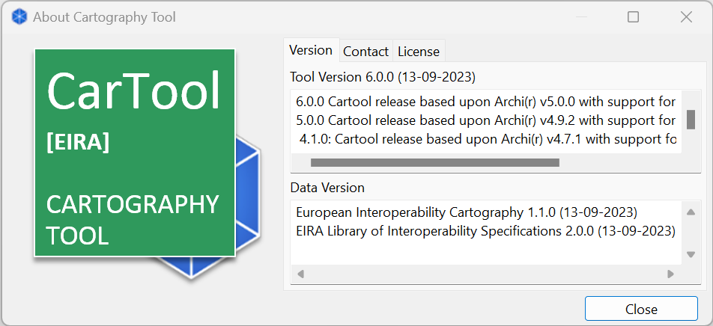

Doing so brings up a dialog with two tabs:

* **Version**, displaying the current version numbers of the tool and local data copy, including their respective changelogs.
* **Contact,** contact information.
* **License**, to show the CarTool’s licensing information.

# Troubleshooting

The current chapter’s purpose is to help you deal with problems that may arise, propose workarounds and guide you in seeking further help.

## Accessing the log file

Certain errors are reported to you when they occur, such as when manually checking for updates. In other cases however, you may experience behaviour you don’t expect without a visual indication of a problem. The first point to check in such cases is the CarTool’s log file.

The log file is located within the “.cartool6\_0” folder, a subdirectory under Archi’s “./plugins**”** folder, in a file named **cartool.log**. Errors are dated and, although technical, may provide enough information to determine a solution yourself, assuming this relates to your environment (e.g. lack of an internet connection).

The log file will typically be requested of you when you get in contact with the support team.

## Resetting the CarTool to its original state

Use of the CarTool results in its local state being modified, either by saving queries or by receiving data modifications through the tool’s update process. Normally it should never be needed, but if you wish to return to a clean state, reflecting the original first run of the CarTool plug-in following its installation, you may do so by deleting its local data and metadata. To do this:

1. Ensure you are not running Archi®.
2. Locate and delete the “.cartool6\_0” folder under your Archi’s “./plugins” folder.
3. Restart Archi®.

When Archi® restarts you will be running the latest downloaded CarTool plug-in version. If you are using a Cartography, you will need to re-install the Cartography as described in Section 2.3.

## Contacting support

To get additional support, ask questions or provide feedback, please contact the CarTool support team at [DIGIT-EIRA@ec.europa.eu](mailto:DIGIT-EIRA@ec.europa.eu). If contacting to report an error please provide already as an attachment the CarTool log file (information on how to retrieve this in Chapter 9.1, “Accessing the log file”).

## Known issues and workarounds

The following sections list currently known issues, impacts and potential workarounds.

**Brief error popup during tool update process**

* **Description**: On certain Windows environments, when an update to the tool itself (or tool with data) is carried out, a brief error popup is displayed before Archi® automatically restarts. Upon restart the update has completed without problems.
* **Workaround**: Ignore the brief error message; the update process should have been completed successfully.

**Cancelling the restart of Archi® during the tool update process triggers repeated errors**

* **Description**: When a manual or automatic update process results in an update to the tool itself, Archi® needs to restart to complete the update. If at this time unsaved work exists a prompt is displayed to save, not save, or cancel the restart. Cancelling the restart leaves the update process in an unfinished state and any subsequent CarTool actions will result in repeated errors referring to “invalid registry objects”.
* **Workaround**: You can prevent this from happening by confirming an update only once your work is saved. Alternatively, if you proceed and face such errors simply save your work and restart Archi®. Following the restart the new version will have been successfully applied.

**Failure to successfully update**

* **Description**: The tool’s update process should normally complete automatically and revert to its previous state in case of error. There are certain cases however where errors may still occur after the point where they can be reverted (e.g. due to locked file system locations). Alternatively, the version of the CarTool you are running may consistently fail to update potentially due to a bug in its update process.
* **Workaround**: As a first step delete the “.cartool6\_0” folder as described in Chapter 9.2, “Resetting the CarTool to its original state”. If upon restart the update continues to fail, uninstall the CarTool plug-in and install it again as described in Chapter 2, “Installation”.

**Using the last modification date as a query filter**

* **Description**: All EIRA ABBs have a “dct:modified” attribute recording the last modification date for an SBB’s information. Adding this to a query and selecting it as a filter criterion results in an error.
* **Workaround**: Do not filter search results using this attribute. Note that you can still select and use such attributes as part of your reporting columns.

**Overwriting a solution or SAT that is currently open**

* **Description**: When creating a new solution or SAT, or editing one from the Cartography, you are prompted to select a target file for the model on your file system. In case you select an existing file that is already open in Archi® and confirm to overwrite it, the replacement appears to take place but the model remains unchanged.
* **Workaround**: Select another target location or ensure you have closed the existing model from Archi®’s open models’ panel as a first step.

# Glossary

The following table summarises the terms and acronyms mentioned in the document text for ease of reference.

Table 10-1: Terms and acronyms

|  |  |
| --- | --- |
| **Term /Acronym** | **Definition** |
| ABB | Architecture Building Block |
| EIRA | European Interoperability Reference Architecture |
| ELIS | The repository of interoperability solutions for European public administrations provided by Union institutions and Member States, presented in a common format and complying with specific re-usability and interoperability criteria that can be represented on the EIRA. |
| ELAP | The EIRA Library of Architecture Principles is a library containing the architecture principles defining the guidelines for designing interoperable digital public services. The aim of this library is supporting solutions architects when modelling using EIRA. |
| ICT | Information and Communications Technology |
| IES | An Interoperable European Solution is an ICT interoperability solution, developed or used by Public Administrations that facilitate the delivery of electronic Public Services by supporting business capabilities involving cross-border exchange of information between Public Administrations and Public Administrations (or Citizens or Businesses) in support to the implementation and advancement of EU, national or local Public Policies |
| JAR | Java Archive |
| SAT | A Solution Architecture Template is an EIRA-based blueprint for specific types of solutions, potentially in specific domains |
| SBB | Solution Building Block |
| Solution | Refers to an ICT solution that can be a software component, a service or a complete software suite |
| URL | Uniform Resource Locator |
| PURI | Persistent Unique Identifier |

1. CarTool source repository: <https://webgate.ec.europa.eu/CITnet/stash/projects/CARTOOL/repos/cartoolplugin/browse> Public CarTool source repository: https://github.com/CarTool-EC/CartTool-v4.0.0 [↑](#footnote-ref-2)
2. Latest EIRA version: <https://joinup.ec.europa.eu/solution/eira/about> [↑](#footnote-ref-3)
3. EIRA on Joinup: <https://joinup.ec.europa.eu/collection/european-interoperability-reference-architecture-eira> [↑](#footnote-ref-4)
4. Archi® download page: <http://www.archimatetool.com/download> [↑](#footnote-ref-5)
5. The latest CarTool build is available at: <https://joinup.ec.europa.eu/solution/cartography-tool> [↑](#footnote-ref-6)
6. The latest CarTool build is available at: <https://joinup.ec.europa.eu/solution/cartography-tool> [↑](#footnote-ref-7)
7. Archi® download page: <http://www.archimatetool.com/download> [↑](#footnote-ref-8)
8. One of the primary purposes of an SAT is to propose interoperability specifications linked to its ABBs that act as requirements in the selection of appropriate SBBs when modelling a solution. [↑](#footnote-ref-9)